Tim Burton. The Melancholy Death of Oyster Boy & Other Stories

Stick Boy and Match Girl in Love
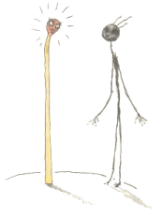
Stick Boy liked Match Girl,
He liked her a lot.
He liked her cute figure,
He thought she was hot.
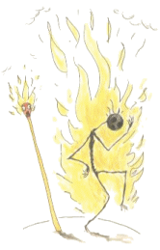
But could a flame ever burn
for a match and a stick?
It did quite literally;
he burned up quick.

Voodoo Girl
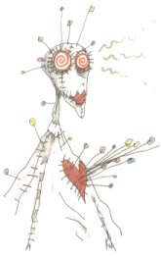
Her skin is white cloth,
and she's all sewn apart
and she has many colored pins
sticking out of her heart.
She has many different zombies
who are deeply in her trance.
She even has a zombie
who was originally from France.
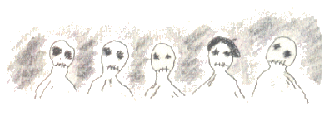
But she knows she has a curse on her,
a curse she cannot win.
For if someone gets
too close to her,
the pins stick farther in.


Robot Boy
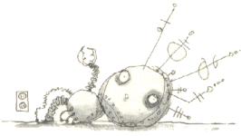
Mr. an Mrs. Smith had a wonderful life.
They were a normal, happy husband and wife.
One day they got news that made Mr. Smith glad.
Mrs. Smith would would be a mom
Which would make him the dad!
But something was wrong with their bundle of joy.
It wasn't human at all, it was a robot boy!
He wasn't warm and cuddly and he didn't have skin.
Instead there was a cold, thin layer of tin.
There were wires and tubes sticking out of his head.
He just lay there and stared, not living or dead.
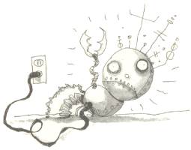
The only time he seemed alive at all
Was with a long extension cord
Plugged into the wall.
Mr. Smith yelled at the doctor,
"What have you done to my boy?
He's not flesh and blood,
he's aluminum alloy!"
The doctor said gently,
"What I'm going to say
will sound pretty wild.
But you're not the father
of this strange looking child.
You see, there still is some question
about the child's gender,
but we think that its father
is a microwave blender."
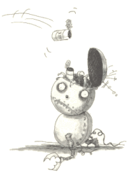
The Smith's lives were now filled
With misery and strife.
Mrs. Smith hated her husband,
And he hated his wife.
He never forgave her unholy alliance:
A sexual encounter with a kitchen appliance.
And Robot Boy grew to be a young man.
Though he was often mistaken for a garbage can.

Staring Girl
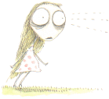
I once knew a girl
Who would just stand there and stare.
At anyone or anything,
She seemed not to care
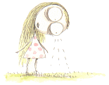
She'd stare at the ground,
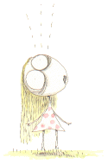
She'd stare at the sky.
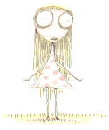
She'd stare at you for hours,
and you'd never know why.
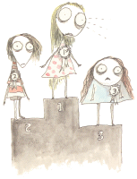
But after winning the local staring contest,
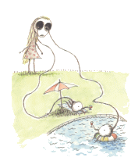
she finally gave her eyes
a well-deserved rest.

The Boy with Nails in His Eyes
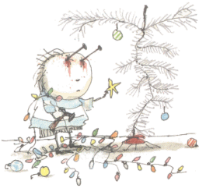
The Boy with Nails in his Eyes
put up his aluminium tree.
It looked pretty strange
because he couldn't really see.

The Girl with Many Eyes
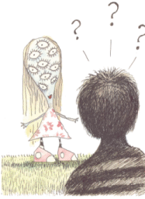
One day in the park
I had quite a surprise.
I met a girl
who had many eyes.
She was really quite pretty
(and also quite shocking!)
and I noticed she had a mouth,
so we ended up talking.
We talked about flowers,
and her poetry classes,
and the problems she'd have
if she ever wore glasses.
It's great to now a girl
who has so many eyes,
but you really get wet
when she breaks down and cries.

Stain Boy
Of all the super heroes,
the strangest one by far,
doesn't have a special power,
or drive a fancy car.
next to Superman and batman, I guess he must seem tame.
But to me he is quite special,
and Stain Boy is his name.
He can't fly around tall buildings,
or outrun a speeding train,
the only talent he seems to have
is to leave a nasty stain.
Sometimes I know it bothers him,
that he can't run or swim or fly,
and because of this one ability,
his dry cleaning bill is sky-high.
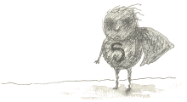

The Melancholy Death of Oyster Boy
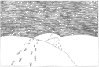
He proposed in the dunes,
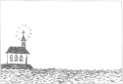
they were wed by the sea,
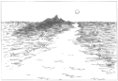
Their nine-day-long honeymoon
was on the isle of Capri.
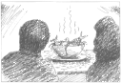
For their supper they had one specatular dish-
a simmering stew of mollusks and fish.
And while he savored the broth,
her bride's heart made a wish.
That wish came true-she gave birth to a baby.
But was this little one human
Well, maybe.
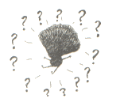
Ten fingers, ten toes,
he had plumbing and sight.
He could hear, he could feel,
but normal?
Not quite.
This unnatural birth, this canker, this blight,
was the start and the end and the sum of their plight.
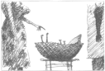
She railed at the doctor:
"He cannot be mine.
He smells of the ocean, of seaweed and brine."
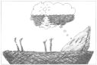
"You should count yourself lucky, for only last week,
I treated a girl with three ears and a beak.
That your son is half oyster
you cannot blame me.
...have you ever considered, by chance,
a small home by the sea?"
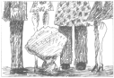
Not knowing what to name him,
they just called him Sam,
or sometimes,
"that thing that looks like a clam"
Everyone wondered, but no one could tell,
When would young Oyster Boy come out of his shell?
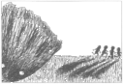
When the Thompson quadruplets espied him one day,
they called him a bivalve and ran quickly away.
One spring afternoon,
Sam was left in the rain.
At the southwestern corner of Seaview and Main,
he watched the rain water as it swirled
down the drain.
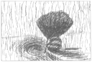
His mom on the freeway
in the breakdown lane
was pouding the dashboard-
she couldn't contain
the ever-rising grief,
frustration,
and pain.
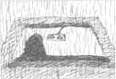
"Really, sweetheart," she said
"I don't mean to make fun,
but something smells fishy
and I think it's our son.
I don't like to say this, but it must be said,
you're blaming our son for your problems in bed."
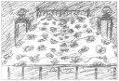
He tried salves, he tried ointments
that turned everything red.
He tried potions and lotions
and tincture of lead.
He ached and he itched and he twitched and he bled.
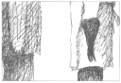
The doctor diagnosed,
"I can't quite be sure,
but the cause of the problem may also be the cure.
They say oysters improve your sexual powers.
Perhaps eating your son
would help you do it for hours!"
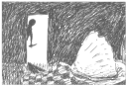
He came on tiptoe,
he came on the sly,
sweat on his forehead,
and on his lips-a lie.
"Son, are you happy? I don't mean to pry,
but do you dream of Heaven?
Have you ever wanted to die?
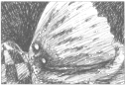
Sam blinked his eye twice.
but made no reply.
Dad fingered his knife and loosened his tie.
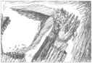
As he picked up his son,
Sam dripped on his coat.
With the shell to his lips,
Sam slipped down his throat.
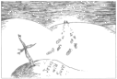
They buried him quickly in the sand by the sea
-sighed a prayer, wept a tear-
and they were back home by three.
A cross of gray driftwood marked Oyster Boy's grave.
Words writ in the sand
promised Jesus would save.
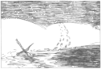
But his memory was lost with one high-tide wave.

Stain Boy’s Special Christmas
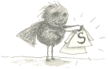
For Christmas, Stain Boy got a new uniform.
It was clean and well pressed,
comfy and warm.

But in few short minutes,
(no longer than ten)
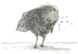
those wet, greasy stains
started forming again.

The Girl Who Turned into a Bed
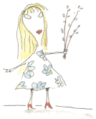
It happened that day
she picked up a strange pussy willow.
Her head swelled up white
and a soft as a pillow.
Her skin, which had turned
all flaky and rotten,
was now replaced
with 100% cotton.
Through her organs and torso
she sprouted like wings,
a beautiful set
of matress and springs.
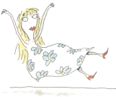
It was so terribly strange
that I started to weep.
But at least after that
I had a nice place to sleep
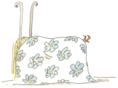

Roy, the Toxic Boy
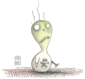
To those who knew him
-his friends-
we called him Roy.
To others he was known
as that horrible Toxic Boy.
He loved ammonia and asbestos,
and lots of cigarette smoke.
What he breathed in for air
would make other people choke!
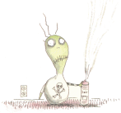
His very favorite toy
was a can of aerosol spray;
he'd sit quietly and shake it,
and spray it all the day.
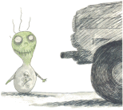
He'd stand inside the garage
in the early-morning frost,
waiting for the car to start
and fill him with exhaust.
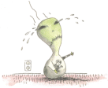
The one and only time
I ever saw Toxic Boy cry
was when some sodium chloride
got into his eye.
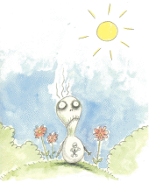
One day for fresh air
they put him in the garden.
His face went deathly pale
and his body began to harden.
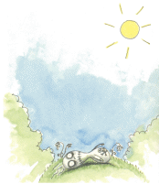
The final gasp of his short life
was sickly with despair.
Whoever thought that you could die
from breathing outdoor air?
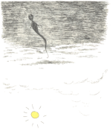
As Roy's soul left his body
we all said a silent prayer.
It drifted up to heaven
and left a hole in the ozone layer.

James
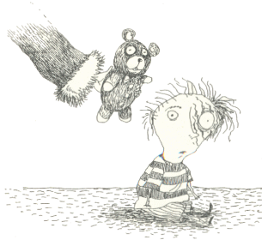
Unwisely, Santa offered a teddy bear to James, unaware that
he had been mauled by a grizzly earlier that year

Stick Boy’s Festive Season
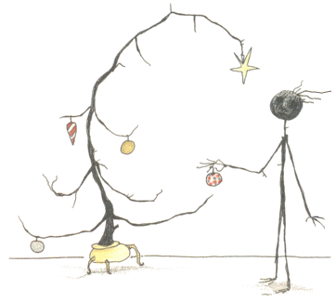
Stick Boy noticed that his Christmas tree looked healthier
than he did.

Brie Boy
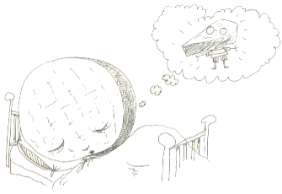
Brie Boy had a dream he had only had twice,
that his full, round head was only a slice.
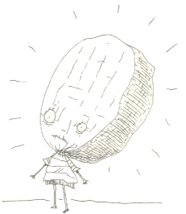
The other children never let Brie Boy play ...
... but at least he went well with a nice Chardonnay.

Mummy Boy
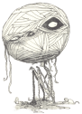
He wasn't soft and pink
witha fat little tummy;
he was hard and hollow,
a little boy mummy.
"Tell us, please, Doctor,
the reason or cause,
why our gundle of joy
is just a bundle of gauze."
"My diagnosis," he said
"for better or worse,
is that your son is the result
of an old pharoah's curse."
That night they talked
of their son's odd condition-
they called him "a reject
from an archaeological expidition."
They thought of some complex
scientific explanation,
but assumed it was simple
supernatural reincarnation.
With the other young tots
he only played twice,
an ancient game of virgin sacrifice.
(But the kids ran away, saying, "You aren't very nice.")
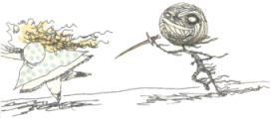
alone and rejected, Mummy Boy wept,
then went to the cabinet
where the snack food was kept.
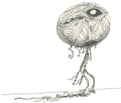
He wiped his wet slockets with his mummified sleeves,
and sat down to a bowl of sugar-frosted tanna leaves.
One dark, gloomy day,
from out of the fog,
appeared a little white mummy dog.
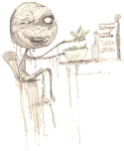
For his newfound wrapped pet,
he did many things,
like building a dog house
à la Pryimid of kings.
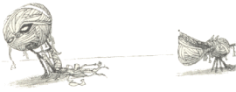
It was late in day-
just before dark.
Mummy Boy took his dog
for a walk in the park.
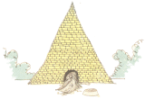
The park was empty
except for a squirrel,
and a birthday party for a Mexican girl.
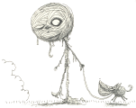
The boys and girls had all started to play,
but noticed that thing that looked like a papíer mâché.
"Look its a piñata,"
said one of the boys,
"Let's crack it wide open
and get the candy and toys."
They took a baseball bat
and whacked open his head.
Mummy Boy fell to the ground;
he finally was dead.
Inside of his head
were no candy or prizes,
jast a few stray bettles
of various sizes.
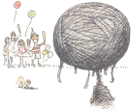

Junk Girl
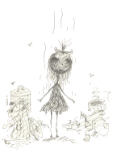
There once was a girl
who was made up of junk.
She looked really dirty,
and she smelled like a skunk.
She was always unhappy,
or in one of her slumps-perhaps 'cause she spent
so much time down in the dumps.
The only bright moment
was from a guy named Stan.
He was from the neighborhood
garbage man.
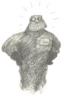
He loved her a lot
and made a marriage proposal,
but she already thrown herself
in the garbage disposal.
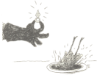

The Pin Cushion Queen
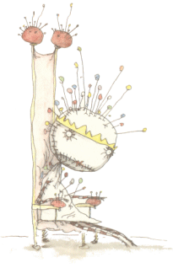
Life isn't easy
for the Pin Cushion Queen.
When she sits alone on her throne
Pins push through her spleen.

Melonhead
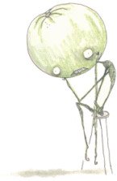
There once was a morose melonhead,
who sat there all day
and wished he were dead.
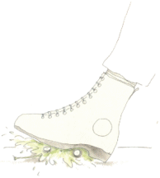
But you should be careful
about the things that you wish.
Because the last thing he heard
was a deafening squish.

Sue
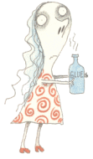
To avoid a law suit,
we'll just call her Sue
(or "that girl who likes
to sniff lots of glue").
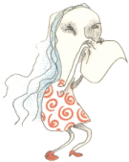
The reason I know
that this is the case
is when she blow her nose,
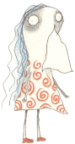
kleenex sticks to her face.

Jimmy, the Hideous Penguin Boy
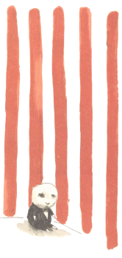
"My name is Jimmy,
but my friends just call me
'the hideous penguin boy.'"

Char Boy
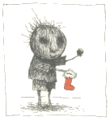
For Christmas, Char boy received his usual lumps of coal,
which made him very happy
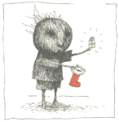
For Christmas, Char Boy received a small present instead of
his usual lump of coal,
which confused him very much.
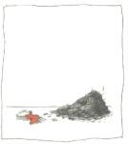
For Christmas Char Boy was mistaken for a dirty fireplace
and swept out into the street.

Anchor Baby
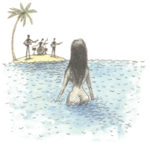
There was a beautiful girl
who came from the sea.
And there was just one place
that she wanted to be.
With a man named Walker
who played in a band.
She would leave the ocean
and come onto the land.
He was the one that she wanted the most.
And she tried everything
to capture this ghost.
But throughout all their lives
they never connected.
She wandered the earth
alone and rejected
She tried looking happy
she tried looking tragic,
she tried astral projecting,
sex, and black magic.
Nothing could join them,
except maybe one thing,
just maybe...
something to anchor their spirits....
They had a baby.
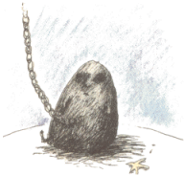
But to give birth to a baby
they needed a crane.
the umbilical cord
was in the form of a chain.
I t was ugly and gloomy,
and as hard as a kettle.
It had no pink skin,
just heavy gray metal.
The baby that was meant to bring them together,
just shrouded them both
in a cloud of foul weather.
So Walker took off
to play with the band.
And from that day on,
he stayed mainly on land.
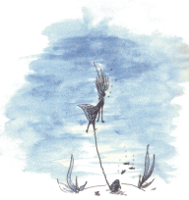
And she was alone
with her gray baby anchor,
who got so oppressive
that eventually sank her.
As she went to the bottom,
not fulfilling her wish,
it was her, and her baby ...
and a few scattered fish.

Oyster Boy Steps Out
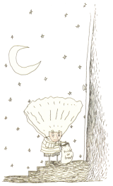
For Halloween,
Oyster Boy decided to go as a human.

Contents

Stick Boy and Match Girl in Love 1
Voodoo Girl 2
Robot Boy 4
Staring Girl 6
The Boy with Nails in His Eyes 8
The Girl with Many Eyes 9
Stain Boy 10
The Melancholy Death of Oyster Boy 11
Stain Boy’s Special Christmas 16
The Girl Who Turned into a Bed 17
Roy, the Toxic Boy 18
James 21
Stick Boy’s Festive Season 22
Brie Boy 23
Mummy Boy 24
Junk Girl 27
The Pin Cushion Queen 28
Melonhead 29
Sue 30
Jimmy, the Hideous Penguin Boy 31
Char Boy 32
Anchor Baby 33
Oyster Boy Steps Out 35
Contents 36

