E.A.Poe
The Haunted Palace
In the greenest of our valleys
By good angels tenanted,
Once a fair and stately palace-
Radiant palace- reared its head.
In the monarch Thought's dominion-
It stood there!
Never seraph spread a pinion
Over fabric half so fair!

Banners yellow, glorious, golden,
On its roof did float and flow,
(This – all this – was in the olden
Time long ago,)
And every gentle air that dallied,
In that sweet day,
Along the ramparts plumed and pallid,
A winged odor went away.

Wanderers in that happy valley,
Through two luminous windows, saw
Spirits moving musically,
To a lute's well-tuned law,
Round about a throne where, sitting
(Porphyrogene!)
In state his glory well-befitting,
The ruler of the realm was seen.

And all with pearl and ruby glowing
Was the fair palace door,
Through which came flowing, flowing, flowing,
And sparkling evermore,
A troop of Echoes, whose sweet duty
Was but to sing,
In voices of surpassing beauty,
The wit and wisdom of their king.

But evil things, in robes of sorrow,
Assailed the monarch's high estate.
(Ah, let us mourn!- for never morrow
Shall dawn upon him desolate!)
And round about his home the glory
That blushed and bloomed,
Is but a dim-remembered story
Of the old time entombed.

And travellers, now, within that valley,
Through the red-litten windows see
Vast forms, that move fantastically
To a discordant melody,
While, like a ghastly rapid river,
Through the pale door
A hideous throng rush out forever
And laugh- but smile no more.

Dreamland
By a route obscure and lonely,
Haunted by ill angels only,
Where an Eidolon, named NIGHT,
On a black throne reigns upright,
I have reached these lands but newly
From an ultimate dim Thule-
From a wild clime that lieth, sublime,
Out of SPACE- out of TIME.

Bottomless vales and boundless floods,
And chasms, and caves, and Titan woods,
With forms that no man can discover
For the tears that drip all over;
Mountains toppling evermore
Into seas without a shore;
Seas that restlessly aspire,
Surging, unto skies of fire;
Lakes that endlessly outspread
Their lone waters- lone and dead,-
Their still waters- still and chilly
With the snows of the lolling lily.

By the lakes that thus outspread
Their lone waters, lone and dead,-
Their sad waters, sad and chilly
With the snows of the lolling lily,-
By the mountains- near the river
Murmuring lowly, murmuring ever,-
By the grey woods,- by the swamp
Where the toad and the newt encamp-
By the dismal tarns and pools
Where dwell the Ghouls,-
By each spot the most unholy-
In each nook most melancholy-
There the traveller meets aghast
Sheeted Memories of the Past-
Shrouded forms that start and sigh
As they pass the wanderer by-
White-robed forms of friends long given,
In agony, to the Earth- and Heaven.

For the heart whose woes are legion
'Tis a peaceful, soothing region-
For the spirit that walks in shadow
'Tis- oh, 'tis an Eldorado!
But the traveller, travelling through it,
May not- dare not openly view it!
Never its mysteries are exposed
To the weak human eye unclosed;
So wills its King, who hath forbid
The uplifting of the fringed lid;
And thus the sad Soul that here passes
Beholds it but through darkened glasses.

By a route obscure and lonely,
Haunted by ill angels only,
Where an Eidolon, named NIGHT,
On a black throne reigns upright,
I have wandered home but newly
From this ultimate dim Thule.

The City in the Sea
Lo! Death has reared himself a throne
In a strange city lying alone
Far down within the dim West,
Where the good and the bad and the worst and the best
Have gone to their eternal rest.
There shrines and palaces and towers
(Time-eaten towers that tremble not!)
Resemble nothing that is ours.
Around, by lifting winds forgot,
Resignedly beneath the sky
The melancholy waters he.

No rays from the holy heaven come down
On the long night-time of that town;
But light from out the lurid sea
Streams up the turrets silently –
Gleams up the pinnacles far and free –
Up domes- up spires- up kingly halls –
Up fanes- up Babylon-like walls –
Up shadowy long-forgotten bowers
Of sculptured ivy and stone flowers –
Up many and many a marvellous shrine
Whose wreathed friezes intertwine
The viol, the violet, and the vine.
Resignedly beneath the sky
The melancholy waters lie.
So blend the turrets and shadows there
That all seem pendulous in air,
While from a proud tower in the town
Death looks gigantically down.

There open fanes and gaping graves
Yawn level with the luminous waves;
But not the riches there that lie
In each idol's diamond eye –
Not the gaily-jewelled dead
Tempt the waters from their bed;
For no ripples curl, alas!
Along that wilderness of glass –
No swellings tell that winds may be
Upon some far-off happier sea –
No heavings hint that winds have been
On seas less hideously serene.

But lo, a stir is in the air!
The wave- there is a movement there!
As if the towers had thrust aside,
In slightly sinking, the dull tide –
As if their tops had feebly given
A void within the filmy Heaven.
The waves have now a redder glow –
The hours are breathing faint and low –
And when, amid no earthly moans,
Down, down that town shall settle hence,
Hell, rising from a thousand thrones,
Shall do it reverence.
Annabel Lee
It was many and many a year ago,
In a kingdom by the sea,
That a maiden there lived whom you may know
By the name of Annabel Lee;
And this maiden she lived with no other thought
Than to love and be loved by me.

I was a child and she was a child,
In this kingdom by the sea;
But we loved with a love that was more than love –
I and my Annabel Lee;
With a love that the winged seraphs of heaven
Coveted her and me.

And this was the reason that, long ago,
In this kingdom by the sea,
A wind blew out of a cloud, chilling
My beautiful Annabel Lee;
So that her highborn kinsman came
And bore her away from me,
To shut her up in a sepulchre
In this kingdom by the sea.

The angels, not half so happy in heaven,
Went envying her and me –
Yes!- that was the reason (as all men know,
In this kingdom by the sea)
That the wind came out of the cloud by night,
Chilling and killing my Annabel Lee.

But our love it was stronger by far than the love
Of those who were older than we –
Of many far wiser than we –
And neither the angels in heaven above,
Nor the demons down under the sea,
Can ever dissever my soul from the soul
Of the beautiful Annabel Lee.

For the moon never beams without bringing me dreams
Of the beautiful Annabel Lee;
And the stars never rise but I feel the bright eyes
Of the beautiful Annabel Lee;
And so, all the night-tide, I lie down by the side
Of my darling- my darling- my life and my bride,
In the sepulchre there by the sea,
In her tomb by the sounding sea.

Spirits of the Dead
Thy soul shall find itself alone
'Mid dark thoughts of the grey tomb-stone;
Not one, of all the crowd, to pry
Into thine hour of secrecy.

Be silent in that solitude,
Which is not loneliness- for then
The spirits of the dead, who stood
In life before thee, are again
In death around thee, and their will
Shall overshadow thee; be still.

The night, though clear, shall frown,
And the stars shall not look down
From their high thrones in the Heaven
With light like hope to mortals given,
But their red orbs, without beam,
To thy weariness shall seem
As a burning and a fever
Which would cling to thee for ever.

Now are thoughts thou shalt not banish,
Now are visions ne'er to vanish;
From thy spirit shall they pass
No more, like dew-drop from the grass.

The breeze, the breath of God, is still,
And the mist upon the hill
Shadowy, shadowy, yet unbroken,
Is a symbol and a token.
How it hangs upon the trees,
A mystery of mysteries!

The Bells
I

Hear the sledges with the bells –
Silver bells!
What a world of merriment their melody foretells!
How they tinkle, tinkle, tinkle,
In the icy air of night!
While the stars that oversprinkle
All the heavens, seem to twinkle
With a crystalline delight;
Keeping time, time, time,
In a sort of Runic rhyme,
To the tintinnabulation that so musically wells
From the bells, bells, bells, bells,
Bells, bells, bells –
From the jingling and the tinkling of the bells.

II

Hear the mellow wedding bells,
Golden bells!
What a world of happiness their harmony foretells!
Through the balmy air of night
How they ring out their delight!
From the molten-golden notes,
And all in tune,
What a liquid ditty floats
To the turtle-dove that listens, while she gloats
On the moon!
Oh, from out the sounding cells,
What a gush of euphony voluminously wells!
How it swells!
How it dwells
On the Future! how it tells
Of the rapture that impels
To the swinging and the ringing
Of the bells, bells, bells,
Of the bells, bells, bells,bells,
Bells, bells, bells –
To the rhyming and the chiming of the bells!

III

Hear the loud alarum bells –
Brazen bells!
What a tale of terror, now, their turbulency tells!
In the startled ear of night
How they scream out their affright!
Too much horrified to speak,
They can only shriek, shriek,
Out of tune,
In a clamorous appealing to the mercy of the fire,
In a mad expostulation with the deaf and frantic fire,
Leaping higher, higher, higher,
With a desperate desire,
And a resolute endeavor,
Now- now to sit or never,
By the side of the pale-faced moon.
Oh, the bells, bells, bells!
What a tale their terror tells
Of Despair!
How they clang, and clash, and roar!
What a horror they outpour
On the bosom of the palpitating air!
Yet the ear it fully knows,
By the twanging,
And the clanging,
How the danger ebbs and flows:
Yet the ear distinctly tells,
In the jangling,
And the wrangling,
How the danger sinks and swells,
By the sinking or the swelling in the anger of the bells –
Of the bells –
Of the bells, bells, bells,bells,
Bells, bells, bells –
In the clamor and the clangor of the bells!

IV

Hear the tolling of the bells –
Iron Bells!
What a world of solemn thought their monody compels!
In the silence of the night,
How we shiver with affright
At the melancholy menace of their tone!
For every sound that floats
From the rust within their throats
Is a groan.
And the people- ah, the people –
They that dwell up in the steeple,
All Alone
And who, tolling, tolling, tolling,
In that muffled monotone,
Feel a glory in so rolling
On the human heart a stone –
They are neither man nor woman –
They are neither brute nor human –
They are Ghouls:
And their king it is who tolls;
And he rolls, rolls, rolls,
Rolls
A paean from the bells!
And his merry bosom swells
With the paean of the bells!
And he dances, and he yells;
Keeping time, time, time,
In a sort of Runic rhyme,
To the paean of the bells –
Of the bells:
Keeping time, time, time,
In a sort of Runic rhyme,
To the throbbing of the bells –
Of the bells, bells, bells –
To the sobbing of the bells;
Keeping time, time, time,
As he knells, knells, knells,
In a happy Runic rhyme,
To the rolling of the bells –
Of the bells, bells, bells:
To the tolling of the bells,
Of the bells, bells, bells, bells –
Bells, bells, bells –
To the moaning and the groaning of the bells.

The Lake. To –
In spring of youth it was my lot
To haunt of the wide world a spot
The which I could not love the less-
So lovely was the loneliness
Of a wild lake, with black rock bound,
And the tall pines that towered around.

But when the Night had thrown her pall
Upon that spot, as upon all,
And the mystic wind went by
Murmuring in melody-
Then- ah then I would awake
To the terror of the lone lake.

Yet that terror was not fright,
But a tremulous delight-
A feeling not the jewelled mine
Could teach or bribe me to define-
Nor Love- although the Love were thine.

Death was in that poisonous wave,
And in its gulf a fitting grave
For him who thence could solace bring
To his lone imagining-
Whose solitary soul could make
An Eden of that dim lake.
The Conqueror Worm
Lo! 'tis a gala night
Within the lonesome latter years!
An angel throng, bewinged, bedight
In veils, and drowned in tears,
Sit in a theatre, to see
A play of hopes and fears,
While the orchestra breathes fitfully
The music of the spheres.

Mimes, in the form of God on high,
Mutter and mumble low,
And hither and thither fly-
Mere puppets they, who come and go
At bidding of vast formless things
That shift the scenery to and fro,
Flapping from out their Condor wings
Invisible Woe!

That motley drama- oh, be sure
It shall not be forgot!
With its Phantom chased for evermore,
By a crowd that seize it not,
Through a circle that ever returneth in
To the self-same spot,
And much of Madness, and more of Sin,
And Horror the soul of the plot.

But see, amid the mimic rout
A crawling shape intrude!
A blood-red thing that writhes from out
The scenic solitude!
It writhes!- it writhes!- with mortal pangs
The mimes become its food,
And seraphs sob at vermin fangs
In human gore imbued.

Out- out are the lights- out all!
And, over each quivering form,
The curtain, a funeral pall,
Comes down with the rush of a storm,
While the angels, all pallid and wan,
Uprising, unveiling, affirm
That the play is the tragedy, "Man",
And its hero the Conqueror Worm.
Ulalume
The skies they were ashen and sober;
The leaves they were crisped and sere –
The leaves they were withering and sere;
It was night in the lonesome October
Of my most immemorial year:
It was hard by the dim lake of Auber,
In the misty mid region of Weir –
It was down by the dank tarn of Auber,
In the ghoul-haunted woodland of Weir.
Here once, through and alley Titanic,
Of cypress, I roamed with my Soul –
Of cypress, with Psyche, my Soul.
These were days when my heart was volcanic
As the scoriac rivers that roll –
As the lavas that restlessly roll
Their sulphurous currents down Yaanek
In the ultimate climes of the pole –
That groan as they roll down Mount Yaanek
In the realms of the boreal pole.
Our talk had been serious and sober,
But our thoughts they were palsied and sere –
Our memories were treacherous and sere, –
For we knew not the month was October,
And we marked not the night of the year
(Ah, night of all nights in the year!) –
We noted not the dim lake of Auber
(Though once we had journeyed down here) –
Remembered not the dank tarn of Auber,
Nor the ghoul-haunted woodland of Weir.
And now, as the night was senescent
And star-dials pointed to morn –
As the star-dials hinted of morn –
At the end of our path a liquescent
And nebulous lustre was born,
Out of which a miraculous crescent
Arose with a duplicate horn –
Astarte's bediamonded crescent
Distinct with its duplicate horn.
And I said: "She is warmer than Dian;
She rolls through an ether of sighs –
She revels in a region of sighs:
She has seen that the tears are not dry on
These cheeks, where the worm never dies,
And has come past the stars of the Lion
To point us the path to the skies –
To the Lethean peace of the skies –
Come up, in despite of the Lion,
To shine on us with her bright eyes –
Come up through the lair of the Lion,
With love in her luminous eyes."
But Psyche, uplifting her finger,
Said: "Sadly this star I mistrust –
Her pallor I strangely mistrust:
Ah, hasten! -ah, let us not linger!
Ah, fly! -let us fly! -for we must."
In terror she spoke, letting sink her
Wings until they trailed in the dust –
In agony sobbed, letting sink her
Plumes till they trailed in the dust –
Till they sorrowfully trailed in the dust.
I replied: "This is nothing but dreaming:
Let us on by this tremulous light!
Let us bathe in this crystalline light!
Its Sybilic splendour is beaming
With Hope and in Beauty tonight! –
See! -it flickers up the sky through the night!
Ah, we safely may trust to its gleaming,
And be sure it will lead us aright –
We safely may trust to a gleaming,
That cannot but guide us aright,
Since it flickers up to Heaven through the night."
Thus I pacified Psyche and kissed her,
And tempted her out of her gloom –
And conquered her scruples and gloom;
And we passed to the end of the vista,
But were stopped by the door of a tomb –
By the door of a legended tomb;
And I said: "What is written, sweet sister,
On the door of this legended tomb?"
She replied: "Ulalume -Ulalume –
'Tis the vault of thy lost Ulalume!"
Then my heart it grew ashen and sober
As the leaves that were crisped and sere –
As the leaves that were withering and sere;
And I cried: "It was surely October
On this very night of last year
That I journeyed -I journeyed down here! –
That I brought a dread burden down here –
On this night of all nights in the year,
Ah, what demon hath tempted me here?
Well I know, now, this dim lake of Auber –
This misty mid region of Weir –
Well I know, now, this dank tarn of Auber,
This ghoul-haunted woodland of Weir."

The Raven
Once upon a midnight dreary, while I pondered, weak and weary,
Over many a quaint and curious volume of forgotten lore –
While I nodded, nearly napping, suddenly there came a tapping,
As of some one gently rapping, rapping at my chamber door.
"'Tis some visiter," I muttered, "tapping at my chamber door –
Only this and nothing more."

Ah, distinctly I remember it was in the bleak December,
And each separate dying ember wrought its ghost upon the floor.
Eagerly I wished the morrow; – vainly I had sought to borrow
From my books surcease of sorrow – sorrow for the lost Lenore –
For the rare and radiant maiden whom the angels name Lenore –
Nameless here for evermore.

And the silken sad uncertain rustling of each purple curtain
Thrilled me – filled me with fantastic terrors never felt before;
So that now, to still the beating of my heart, I stood repeating
"'Tis some visiter entreating entrance at my chamber door –
Some late visiter entreating entrance at my chamber door;
This it is and nothing more."

Presently my soul grew stronger; hesitating then no longer,
"Sir," said I, "or Madam, truly your forgiveness I implore;
But the fact is I was napping, and so gently you came rapping,
And so faintly you came tapping, tapping at my chamber door,
That I scarce was sure I heard you" – here I opened wide the door –
Darkness there and nothing more.

Deep into that darkness peering, long I stood there wondering, fearing,
Doubting, dreaming dreams no mortals ever dared to dream before;
But the silence was unbroken, and the stillness gave no token,
And the only word there spoken was the whispered word, "Lenore?"
This I whispered, and an echo murmured back the word, "Lenore!" –
Merely this and nothing more.

Back into the chamber turning, all my soul within me burning,
Soon again I heard a tapping something louder than before.
"Surely," said I, "surely that is something at my window lattice;
Let me see, then, what thereat is and this mystery explore –
Let my heart be still a moment and this mystery explore; –
'Tis the wind and nothing more.

Open here I flung the shutter, when, with many a flirt and flutter,
In there stepped a stately Raven of the saintly days of yore.
Not the least obeisance made he; not a minute stopped or stayed he,
But, with mien of lord or lady, perched above my chamber door –
Perched upon a bust of Pallas just above my chamber door –
Perched, and sat, and nothing more.

Then the ebony bird beguiling my sad fancy into smiling,
By the grave and stern decorum of the countenance it wore,
"Though thy crest be shorn and shaven, thou," I said, "art sure no craven,
Ghastly grim and ancient Raven wandering from the Nightly shore –
Tell me what thy lordly name is on the Night's Plutonian shore!"
Quoth the Raven, "Nevermore."

Much I marvelled this ungainly fowl to hear discourse so plainly,
Though its answer little meaning – little relevancy bore;
For we cannot help agreeing that no living human being
Ever yet was blessed with seeing bird above his chamber door –
Bird or beast upon the sculptured bust above his chamber door,
With such name as "Nevermore."

But the Raven, sitting lonely on that placid bust, spoke only
That one word, as if its soul in that one word he did outpour
Nothing farther then he uttered; not a feather then he fluttered –
Till I scarcely more than muttered: "Other friends have flown before –
On the morrow he will leave me, as my Hopes have flown before."
Then the bird said "Nevermore."

Startled at the stillness broken by reply so aptly spoken,
"Doubtless," said I, "what it utters is its only stock and store,
Caught from some unhappy master whom unmerciful Disaster
Followed fast and followed faster till his songs one burden bore –
Till the dirges of his Hope that melancholy burden bore
Of 'Never – nevermore.'"

But the Raven still beguiling all my sad soul into smiling,
Straight I wheeled a cushioned seat in front of bird and bust and door;
Then, upon the velvet sinking, I betook myself to linking
Fancy unto fancy, thinking what this ominous bird of yore –
What this grim, ungainly, ghastly, gaunt, and ominous bird of yore
Meant in croaking "Nevermore."

This I sat engaged in guessing, but no syllable expressing
To the fowl whose fiery eyes now burned into my bosom's core;
This and more I sat divining, with my head at ease reclining
On the cushion's velvet lining that the lamp-light gloated o'er,
But whose velvet violet lining with the lamp-light gloating o'er
She shall press, ah, nevermore!

Then, methought, the air grew denser, perfumed from an unseen censer
Swung by Seraphim whose foot-falls tinkled on the tufted floor.
"Wretch," I cried, "thy God hath lent thee – by these angels he hath sent thee
Respite – respite and nepenthe from thy memories of Lenore!
Quaff, oh quaff this kind nepenthe and forget this lost Lenore!"
Quoth the Raven, "Nevermore."

"Prophet!" said I, "thing of evil! – prophet still, if bird or devil! –
Whether Tempter sent, or whether tempest tossed thee here ashore,
Desolate, yet all undaunted, on this desert land enchanted –
On this home by Horror haunted – tell me truly, I implore –
Is there – is there balm in Gilead? – tell me – tell me, I implore!"
Quoth the Raven, "Nevermore."

"Prophet!" said I, "thing of evil! – prophet still, if bird or devil!
By that Heaven that bends above us – by that God we both adore –
Tell this soul with sorrow laden if, within the distant Aidenn,
It shall clasp a sainted maiden whom the angels name Lenore –
Clasp a rare and radiant maiden whom the angels name Lenore."
Quoth the Raven, "Nevermore."

"Be that our sign of parting, bird or fiend!" I shrieked, upstarting –
"Get thee back into the tempest and the Night's Plutonian shore!
Leave no black plume as a token of that lie thy soul has spoken!
Leave my loneliness unbroken! – quit the bust above my door!
Take thy beak from out my heart, and take thy form from off my door!"
Quoth the Raven, "Nevermore."

And the Raven, never flitting, still is sitting, still is sitting
On the pallid bust of Pallas just above my chamber door;
And his eyes have all the seeming of a demon's that is dreaming
And the lamp-light o'er him streaming throws his shadows on the floor;
And my soul from out that shadow that lies floating on the floor
Shall be lifted – nevermore!

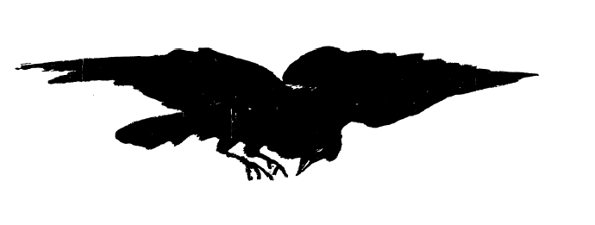

Более другие поэты
T. Hood.
No!
No sun –no moon!
No morn –no noon!
No dawn –no dusk –no proper time of day –
No sky –no earthly view –
No distance looking blue –
No road –no street –no "t'other side this way" –
No end to any Row –
No indications where the Crescents go –
No top to any steeple –
No recognitions of familiar people –
No courtesies for showing 'em –
No knowing 'em!
No traveling at all –no locomotion –
No inkling of the way –no notion –
"No go" by land or ocean –
No mail –no post –
No news from any foreign coast –
No Park, no Ring, no afternoon gentility –
No company –no nobility –
No warmth, no cheerfulness, no healthful ease,
No comfortable feel in any member –
No shade, no shine, no butterflies, no bees,
No fruits, no flowers, no leaves, no birds –
November!

K.Weill & M. Anderson.
September Song
For it's a long, long time from may to december
And the days grow short when you reach september
And the autumn weather turns the leaves to flame
And I haven't got time for the waiting game

Chorus:
And the days dwindle down to a precious few
September november
And these few precious days I'd spend with you
These golden days I'd spend with you

When you meet with the young man early in spring
They court you in song and rhyme
They woo you with words and a clover ring
But if you examine the goods they bring
They have little to offer but the songs they sing
And a plentiful waste of time of day
A plentiful waste of time

Chorus.

W.H.Auden.
Funeral Blues
Stop all the clocks, cut off the telephone,
Prevent the dog from barking with a juicy bone,
Silence the pianos and with muffled drum
Bring out the coffin, let the mourners come.

Let aeroplanes circle moaning overhead
Scribbling on the sky the message “He Is Dead”
Put crepe bows round the white necks of the public doves
Let the traffic policemen wear black cotton gloves

He was my North, my South, my East and West
My working week and my Sunday rest
My moon, my midnight, my talk, my song;
I thought that love would last forever: I was wrong.

The stars are not wanted now; put out everyone;
Pack up the Moon and dismantle the Sun;
Pour away the ocean and sweep up the wood;
For nothing now can ever come to any good.

R. Kipling.
Tomlinson
Now Tomlinson gave up the ghost at his house in Berkeley Square,
And a Spirit came to his bedside and gripped him by the hair –

A Spirit gripped him by the hair and carried him far away,
Till he heard as the roar of a rain-fed ford the roar of the Milky Way:

Till he heard the roar of the Milky Way die down and drone and cease,
And they came to the Gate within the Wall where Peter holds the keys.

"Stand up, stand up now, Tomlinson, and answer loud and high
"The good that ye did for the sake of men or ever ye came to die –

"The good that ye did for the sake of men on the little Earth so lone!"
And the naked soul of Tomlinson grew white as the rain-washed bone.

"O I have a friend on Earth," he said, "that was my priest and guide,
"And well would he answer all for me if he were at my side."

–"For that ye strove in neighbour-love it shall be written fair,
"But now ye wait at Heaven's Gate and not in Berkeley Square:

"Though we called your friend from his bed this night, he could not speak for you,
"For the race is run by one and one and never by two and two."

Then Tomlinson looked up and down, and little gain was there,
For the naked stars grinned overhead, and he saw that his soul was bare.

The Wind that blows between the Worlds, it cut him like a knife,
And Tomlinson took up the tale and spoke of his good in life.

"O this I have read in a book," he said, "and that was told to me,
"And this I have thought that another man thought of a Prince in Muscovy."

The good souls flocked like homing doves and bade him clear the path,
And Peter twirled the jangling Keys in weariness and wrath.

"Ye have read, ye have heard, ye have thought," he said, "and the tale is yet to run:
"By the worth of the body that once ye had, give answer –what ha' ye done?"

Then Tomlinson looked back and forth, and little good it bore,
For the darkness stayed at his shoulder-blade and Heaven's Gate before: –

"O this I have felt, and this I have guessed, and this I heard men say,
"And this they wrote that another man wrote of a carl in Norroway."

"Ye have read, ye have felt, ye have guessed, good lack! Ye have hampered Heaven's Gate;
"There's little room between the stars in idleness to prate!

"For none may reach by hired speech of neighbour, priest, and kin
"Through borrowed deed to God's good meed that lies so fair within;

"Get hence, get hence to the Lord of Wrong, for thy doom has yet to run,
"And... the faith that ye share with Berkeley Square uphold you, Tomlinson!"

The Spirit gripped him by the hair, and sun by sun they fell
Till they came to the belt of Naughty Stars that rim the mouth of Hell.

The first are red with pride and wrath, the next are white with pain,
But the third are black with clinkered sin that cannot burn again.

They may hold their path, they may leave their path, with never a soul to mark:
They may burn or freeze, but they must not cease in the Scorn of the Outer Dark.

The Wind that blows between the Worlds, it nipped him to the bone,
And he yearned to the flare of Hell-gate there as the light of his own hearth-stone.

The Devil he sat behind the bars, where the desperate legions drew,
But he caught the hasting Tomlinson and would not let him through.

"Wot ye the price of good pit-coal that I must pay?" said he,
"That ye rank yoursel' so fit for Hell and ask no leave of me?

"I am all o'er-sib to Adam's breed that ye should give me scorn,
"For I strove with God for your First Father the day that he was born.

"Sit down, sit down upon the slag, and answer loud and high
"The harm that ye did to the Sons of Men or ever you came to die."

And Tomlinson looked up and up, and saw against the night
The belly of a tortured star blood-red in Hell-Mouth light;

And Tomlinson looked down and down, and saw beneath his feet
The frontlet of a tortured star milk-white in Hell-Mouth heat.

"O I had a love on earth," said he, "that kissed me to my fall;
"And if ye would call my love to me I know she would answer all."

–"All that ye did in love forbid it shall be written fair,
"But now ye wait at Hell-Mouth Gate and not in Berkeley Square:

"Though we whistled your love from her bed to-night, I trow she would not run,
"For the sin that ye do by two and two ye must pay for one by one!"

The Wind that blows between the Worlds, it cut him like a knife,
And Tomlinson took up the tale and spoke of his sins in life: –

"Once I ha' laughed at the power of Love and twice at the grip of the Grave,
"And thrice I ha' patted my God on the head that men might call me brave."

The Devil he blew on a brandered soul and laid it aside to cool: –
"Do ye think I would waste my good pit-coal on the hide of a brain-sick fool?

"I see no worth in the hobnail mirth or the jolthead jest ye did
"That I should waken my gentlemen that are sleeping three on a grid."

Then Tomlinson looked back and forth, and there was little grace,
For Hell-Gate filled the houseless soul with the Fear of Naked Space.

"Nay, this I ha' heard," quo' Tomlinson, "and this was noised abroad,
"And this I ha' got from a Belgian book on the word of a dead French lord."

–"Ye ha' heard, ye ha' read, ye ha' got, good lack! and the tale begins afresh –
"Have ye sinned one sin for the pride o' the eye or the sinful lust of the flesh?"

Then Tomlinson he gripped the bars and yammered, "Let me in –
"For I mind that I borrowed my neighbour's wife to sin the deadly sin."

The Devil he grinned behind the bars, and banked the fires high:
"Did ye read of that sin in a book?" said he; and Tomlinson said, "Ay!"

The Devil he blew upon his nails, and the little devils ran,
And he said: "Go husk this whimpering thief that comes in the guise of a man:

"Winnow him out 'twixt star and star, and sieve his proper worth:
"There's sore decline in Adam's line if this be spawn of Earth."

Empusa's crew, so naked-new they may not face the fire,
But weep that they bin too small to sin to the height of their desire,

Over the coal they chased the Soul, and racked it all abroad,
As children rifle a caddis-case or the raven's foolish hoard.

And back they came with the tattered Thing, as children after play,
And they said: "The soul that he got from God he has bartered clean away.

"We have threshed a stook of print and book, and winnowed a chattering wind,
"And many a soul wherefrom he stole, but his we cannot find.

"We have handled him, we have dandled him, we have seared him to the bone,
"And, Sire, if tooth and nail show truth he has no soul of his own."

The Devil he bowed his head to his breast and rumbled deep and low: –
"I'm all o'er-sib to Adam's breed that I should bid him go.

"Yet close we lie, and deep we lie, and if I gave him place,
"My gentlemen that are so proud would flout me to my face;

"They'd call my house a common stews and me a careless host,
"And –I would not anger my gentlemen for the sake of a shiftless ghost."

The Devil he looked at the mangled Soul that prayed to feel the flame,
And he thought of Holy Charity, but he thought of his own good name: –

"Now ye could haste my coal to waste, and sit ye down to fry.
"Did ye think of that theft for yourself?" said he; and Tomlinson said, "Ay! "

The Devil he blew an outward breath, for his heart was free from care: –
"Ye have scarce the soul of a louse," he said, "but the roots of sin are there,

"And for that sin should ye come in were I the lord alone,
"But sinful pride has rule inside –ay, mightier than my own.

"Honour and Wit, fore-damned they sit, to each his Priest and Whore;
"Nay, scarce I dare myself go there, and you they'd torture sore.

"Ye are neither spirit nor spirk," he said; "ye are neither book nor brute –
"Go, get ye back to the flesh again for the sake of Man's repute.

"I'm all o'er-sib to Adam's breed that I should mock your pain,
"But look that ye win to a worthier sin ere ye come back again.

"Get hence, the hearse is at your door –the grim black stallions wait –
"They bear your clay to place to-day. Speed, lest ye come too late!

"Go back to Earth with lip unsealed –go back with open eye,
"And carry my word to the Sons of Men or ever ye come to die:

"That the sin they do by two and two they must pay for one by one,
"And... the God you took from a printed book be with you, Tomlinson!"

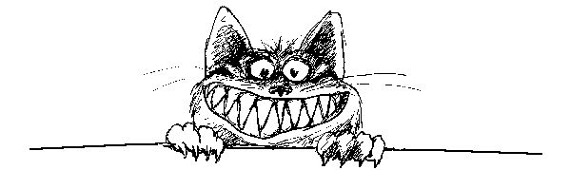

E.A.Poe’s Cat.
The End of the Raven
On a night quite unenchanting, when the rain was downward slanting,
I awakened to the ranting of the man I catch mice for.
Tipsy and a bit unshaven, in a tone I found quite craven,
Poe was talking to a Raven perched above the chamber door.
"Raven's very tasty," thought I, as I tiptoed o'er the floor,
"There is nothing I like more."

Soft upon the rug I treaded, calm and careful as I headed
Towards his roost atop that dreaded bust of Pallas I deplore.
While the bard and birdie chattered, I made sure that nothing clattered,
Creaked, or snapped, or fell, or shattered, as I crossed the corridor;
For his house is crammed with trinkets, curios and weird decor –
Bric-a-brac and junk galore.

Still the Raven never fluttered, standing stock-still as he uttered,
In a voice that shrieked and sputtered, his two cents worth – "Nevermore."
While this dirge the birdbrain kept up, oh, so silently I crept up,
Then I crouched and quickly leapt up, pouncing on the feather bore.
Soon he was a heap of plumage, and a little blood and gore –
Only this and not much more.

Then my pickled poet cried out, "Pussycat, it's time I dried out!"
Never sat I in my hideout talking to a bird before;
How I've wallowed in self-pity, while my gallant, valiant kitty.
Put an end to that damned ditty…” – then I heard him start to snore.
Back atop the door I clambered, eyed that statue I abhor,
Jumped – and smashed it on the floor.

Tim Burton.
The Melancholy Death of Oyster Boy
& Other Stories
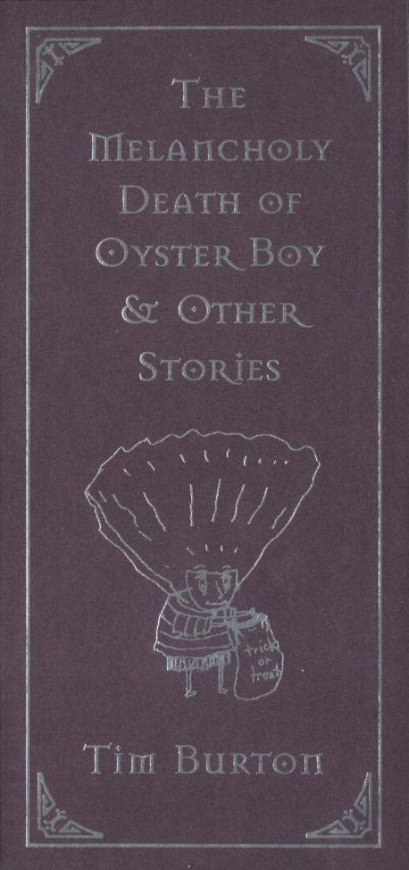

Stick Boy and Match Girl in Love
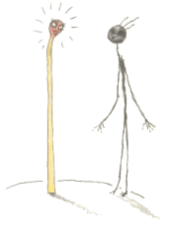
Stick Boy liked Match Girl, he liked her a lot.
He liked her cute figure, he thought she was hot.
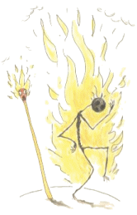
But could a flame ever burn for a match and a stick?
It did quite literally; he burned up quick.

Voodoo Girl
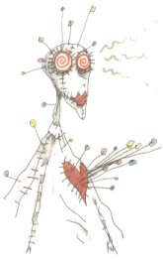
Her skin is white cloth, and she's all sewn apart
And she has many colored pins sticking out of her heart.
She has many different zombies who are deeply in her trance.
She even has a zombie who was originally from France.
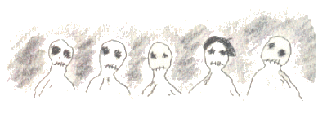
But she knows she has a curse on her, a curse she cannot win.
For if someone gets too close to her…
…the pins stick farther in.


Robot Boy
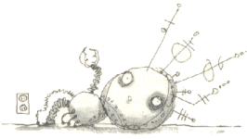
Mr. an Mrs. Smith had a wonderful life.
They were a normal, happy husband and wife.
One day they got news that made Mr. Smith glad.
Mrs. Smith would would be a mom
Which would make him the dad!
But something was wrong with their bundle of joy.
It wasn't human at all, it was a robot boy!
He wasn't warm and cuddly and he didn't have skin.
Instead there was a cold, thin layer of tin.
There were wires and tubes sticking out of his head.
He just lay there and stared, not living or dead.
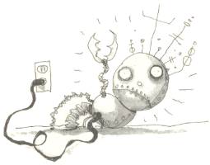
The only time he seemed alive at all
Was with a long extension cord plugged into the wall.
Mr. Smith yelled at the doctor,
"What have you done to my boy?
He's not flesh and blood, he's aluminum alloy!"
The doctor said gently,
"What I'm going to say will sound pretty wild.
But you're not the father of this strange looking child.
You see, there still is some question about the child's gender,
but we think that its father is a microwave blender."
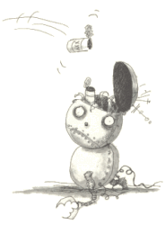
The Smith's lives were now filled with misery and strife.
Mrs. Smith hated her husband, and he hated his wife.
He never forgave her unholy alliance:
A sexual encounter with a kitchen appliance.
And Robot Boy grew to be a young man.
Though he was often mistaken for a garbage can.

Staring Girl
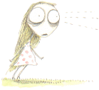
I once knew a girl
Who would just stand there and stare.
At anyone or anything,
She seemed not to care
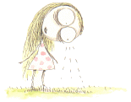
She'd stare at the ground,
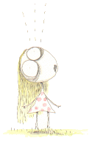
She'd stare at the sky.
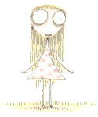
She'd stare at you for hours,
and you'd never know why.
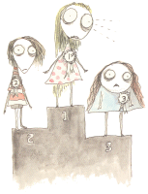
But after winning the local staring contest,
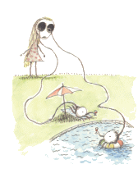
She finally gave her eyes a well-deserved rest.

The Boy with Nails in His Eyes
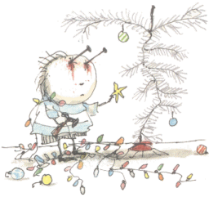
The Boy with Nails in his Eyes
Put up his aluminium tree.
It looked pretty strange
Because he couldn't really see.

The Girl with Many Eyes
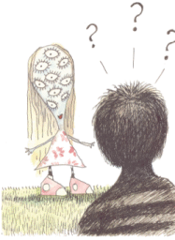
One day in the park
I had quite a surprise.
I met a girl
Who had many eyes.
She was really quite pretty
(and also quite shocking!)
And I noticed she had a mouth,
So we ended up talking.
We talked about flowers,
And her poetry classes,
And the problems she'd have
If she ever wore glasses.
It's great to now a girl
Who has so many eyes,
But you really get wet
When she breaks down and cries.

Stain Boy
Of all the super heroes,
The strangest one by far,
Doesn't have a special power,
Or drive a fancy car.
Next to Superman and Batman,
I guess he must seem tame.
But to me he is quite special,
And Stain Boy is his name.
He can't fly around tall buildings,
Or outrun a speeding train,
The only talent he seems to have
Is to leave a nasty stain.
Sometimes I know it bothers him,
That he can't run or swim or fly,
And because of this one ability,
His dry cleaning bill is sky-high.
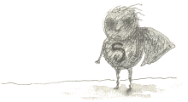

The Melancholy Death of Oyster Boy
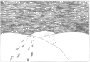
He proposed in the dunes,
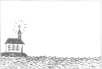
they were wed by the sea,
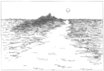
Their nine-day-long honeymoon
Was on the isle of Capri.
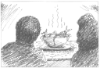
For their supper they had one specatular dish-
A simmering stew of mollusks and fish.
And while he savored the broth,
Her bride's heart made a wish.
That wish came true-she gave birth to a baby.
But was this little one human… Well, maybe.
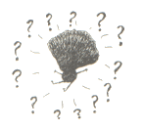
Ten fingers, ten toes, he had plumbing and sight.
He could hear, he could feel, but normal? Not quite.
This unnatural birth, this canker, this blight,
was the start and the end and the sum of their plight.
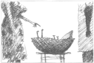
She railed at the doctor: "He cannot be mine.
He smells of the ocean, of seaweed and brine."
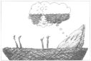
"You should count yourself lucky, for only last week,
I treated a girl with three ears and a beak.
That your son is half oyster you cannot blame me.
...have you ever considered, by chance,
a small home by the sea?"
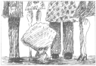
Not knowing what to name him, they just called him Sam,
Or sometimes, "that thing that looks like a clam".
Everyone wondered, but no one could tell,
When would young Oyster Boy come out of his shell?
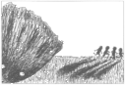
When the Thompson quadruplets espied him one day,
They called him a bivalve and ran quickly away.
One spring afternoon, Sam was left in the rain.
At the southwestern corner of Seaview and Main,
He watched the rain water as it swirled down the drain.
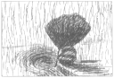
His mom on the freeway in the breakdown lane
Was pounding the dashboard- she couldn't contain
The ever-rising grief, frustration, and pain.
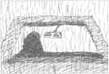
"Really, sweetheart," she said, "I don't mean to make fun,
But something smells fishy and I think it's our son.
I don't like to say this, but it must be said,
You're blaming our son for your problems in bed."
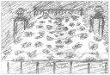
He tried salves, he tried ointments that turned everything red.
He tried potions and lotions and tincture of lead.
He ached and he itched and he twitched and he bled.
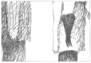
The doctor diagnosed "I can't quite be sure,
But the cause of the problem may also be the cure.
They say oysters improve your sexual powers.
Perhaps eating your son would help you do it for hours!"
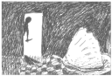
He came on tiptoe, he came on the sly,
Sweat on his forehead, and on his lips-a lie.
"Son, are you happy? I don't mean to pry,
But do you dream of Heaven? Have you ever wanted to die?
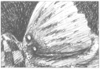
Sam blinked his eye twice, but made no reply.
Dad fingered his knife and loosened his tie.
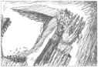
As he picked up his son, Sam dripped on his coat.
With the shell to his lips, Sam slipped down his throat.
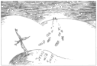
They buried him quickly in the sand by the sea –
Sighed a prayer, wept a tear-and they were back home by three.
A cross of gray driftwood marked Oyster Boy's grave.
Words writ in the sand promised Jesus would save.
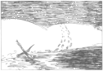
But his memory was lost with one high-tide wave.

Stain Boy’s Special Christmas
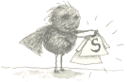
For Christmas, Stain Boy got a new uniform.
It was clean and well pressed, comfy and warm.
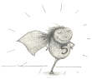
But in few short minutes, (no longer than ten)
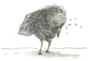
those wet, greasy stains started forming again.

The Girl Who Turned into a Bed
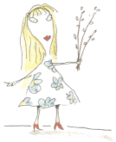
It happened that day she picked up a strange pussy willow.
Her head swelled up white and a soft as a pillow.
Her skin, which had turned all flaky and rotten,
Was now replaced with 100% cotton.
Through her organs and torso she sprouted like wings,
A beautiful set of matress and springs.
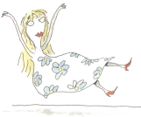
It was so terribly strange that I started to weep.
But at least after that I had a nice place to sleep
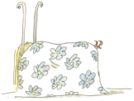

Roy, the Toxic Boy
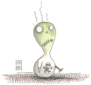
To those who knew him – his friends – we called him Roy.
To others he was known as “that horrible Toxic Boy”.
He loved ammonia and asbestos, and lots of cigarette smoke.
What he breathed in for air would make other people choke!
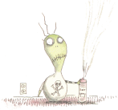
His very favorite toy was a can of aerosol spray;
He'd sit quietly and shake it, and spray it all the day.
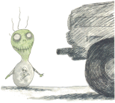
He'd stand inside the garage in the early-morning frost,
Waiting for the car to start and fill him with exhaust.
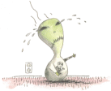
The one and only time I ever saw Toxic Boy cry
Was when some sodium chloride got into his eye.
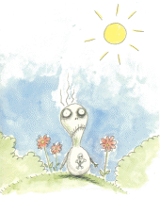
One day for fresh air they put him in the garden.
His face went deathly pale and his body began to harden.
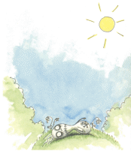
The final gasp of his short life was sickly with despair.
Whoever thought that you could die from breathing outdoor air?
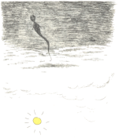
As Roy's soul left his body we all said a silent prayer.
It drifted up to heaven and left a hole in the ozone layer.

James
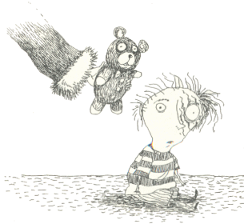
Unwisely, Santa offered a teddy bear to James, unaware that he had been mauled by a grizzly earlier that year

Stick Boy’s Festive Season
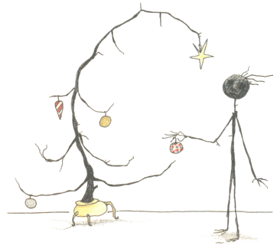
Stick Boy noticed that his Christmas tree looked healthier than he did.

Brie Boy
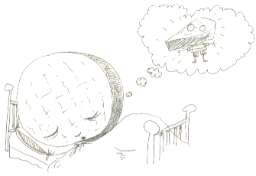
Brie Boy had a dream he had only had twice,
That his full, round head was only a slice.
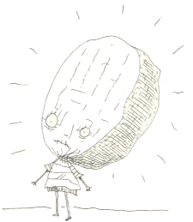
The other children never let Brie Boy play...
...but at least he went well with a nice Chardonnay.

Mummy Boy
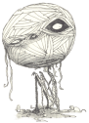
He wasn't soft and pink with a fat little tummy;
He was hard and hollow, a little boy mummy.
"Tell us, please, Doctor, the reason or cause,
Why our gundle of joy is just a bundle of gauze."
"My diagnosis," he said "for better or worse,
Is that your son is the result of an old pharaoh's curse."
That night they talked of their son's odd condition-
They called him "a reject from an archaeological expedition."
They thought of some complex scientific explanation,
But assumed it was simple supernatural reincarnation.
With the other young tots he only played twice,
An ancient game of virgin sacrifice.
(But the kids ran away, saying, "You aren't very nice.")
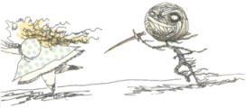
Alone and rejected, Mummy Boy wept,
Then went to the cabinet where the snack food was kept.
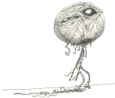
He wiped his wet sockets with his mummified sleeves,
And sat down to a bowl of sugar-frosted tanna leaves.
One dark, gloomy day, from out of the fog,
Appeared a little white mummy dog.
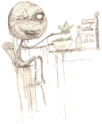
For his newfound wrapped pet, he did many things,
Like building a dog house à la Pryimid of kings.
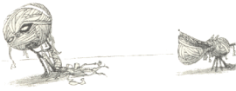
It was late in day- just before dark.
Mummy Boy took his dog for a walk in the park.
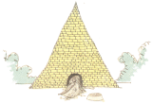
The park was empty except for a squirrel,
And a birthday party for a Mexican girl.
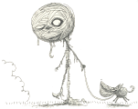
The boys and girls had all started to play,
But noticed that thing that looked like a papier mache.
"Look its a pinata," said one of the boys,
"Let's crack it wide open and get the candy and toys."
They took a baseball bat and whacked open his head.
Mummy Boy fell to the ground; he finally was dead.
Inside of his head were no candy or prizes,
Just a few stray beetles of various sizes.
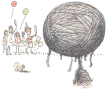

Junk Girl
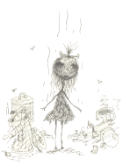
There once was a girl who was made up of junk.
She looked really dirty, and she smelled like a skunk.
She was always unhappy, or in one of her slumps –
Perhaps 'cause she spent so much time down in the dumps.
The only bright moment was from a guy named Stan.
He was from the neighborhood garbage man.
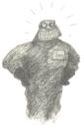
He loved her a lot and made a marriage proposal,
but she already thrown herself in the garbage disposal.
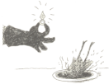

The Pin Cushion Queen
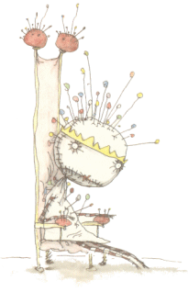
Life isn't easy
For the Pin Cushion Queen.
When she sits alone on her throne
Pins push through her spleen.

Melonhead
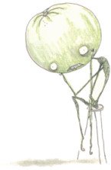
There once was a morose melonhead,
Who sat there all day and wished he were dead.
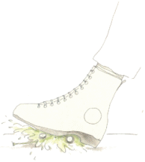
But you should be careful about the things that you wish.
Because the last thing he heard was a deafening squish.

Sue
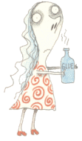
To avoid a law suit, we'll just call her Sue
(or "that girl who likes to sniff lots of glue").
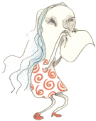
The reason I know that, this is the case,
Is when she blows her nose, kleenex sticks to her face.
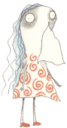

Jimmy, the Hideous Penguin Boy
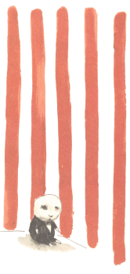
"My name is Jimmy, but my friends just call me 'the hideous penguin boy.'"

Char Boy
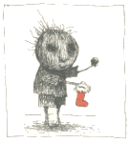
For Christmas, Char boy received his usual lumps of coal, which made him very happy.
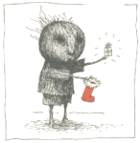
For Christmas, Char Boy received a small present instead of his usual lump of coal, which confused him very much.
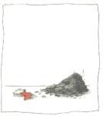
For Christmas, Char Boy was mistaken for a dirty fireplace and swept out into the street.

Anchor Baby
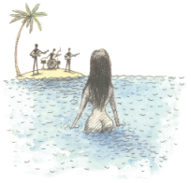
There was a beautiful girl who came from the sea.
And there was just one place that she wanted to be.
With a man named Walker who played in a band.
She would leave the ocean and come onto the land.
He was the one that she wanted the most.
And she tried everything to capture this ghost.
But throughout all their lives they never connected.
She wandered the earth alone and rejected
She tried looking happy she tried looking tragic,
She tried astral projecting, sex, and black magic.
Nothing could join them, except maybe one thing, just maybe...
Something to anchor their spirits...
They had a baby.
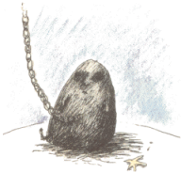
But to give birth to a baby they needed a crane.
The umbilical cord was in the form of a chain.
It was ugly and gloomy, and as hard as a kettle.
It had no pink skin, just heavy gray metal.
The baby that was meant to bring them together,
just shrouded them both in a cloud of foul weather.
So Walker took off to play with the band.
And from that day on, he stayed mainly on land.
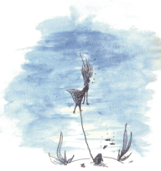
And she was alone with her gray baby anchor,
Who got so oppressive that eventually sank her.
As she went to the bottom, not fulfilling her wish,
It was her, and her baby... and a few scattered fish.

Oyster Boy Steps Out
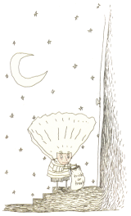
For Halloween, Oyster Boy decided to go as a human.

Contents
E.A.Poe 1
The Haunted Palace 1
Dreamland 2
The City in the Sea 3
Annabel Lee 4
Spirits of the Dead 5
The Bells 6
The Lake. To – 8
The Conqueror Worm 9
Ulalume 10
The Raven 12
Более другие поэты 15
T. Hood. No! 15
K.Weill & M. Anderson. September Song 16
W.H.Auden. Funeral Blues 16
R. Kipling. Tomlinson 17
E.A.Poe’s Cat The End of the Raven 21
Tim Burton. The Melancholy Death of Oyster Boy & Other Stories 22
Stick Boy and Match Girl in Love 23
Voodoo Girl 24
Robot Boy 25
Staring Girl 27
The Boy with Nails in His Eyes 29
The Girl with Many Eyes 30
Stain Boy 31
The Melancholy Death of Oyster Boy 32
Stain Boy’s Special Christmas 36
The Girl Who Turned into a Bed 37
Roy, the Toxic Boy 38
James 40
Stick Boy’s Festive Season 41
Brie Boy 42
Mummy Boy 43
Junk Girl 46
The Pin Cushion Queen 47
Melonhead 48
Sue 49
Jimmy, the Hideous Penguin Boy 50
Char Boy 51
Anchor Baby 52
Oyster Boy Steps Out 54
Contents 55

