A Brief History of Type: 1. Humanist (Incunabula)
Every subject, from dentistry to dog handling has its own vocabulary — terms that are peculiar (unique) to it. Typography is no exception. Learning the lingua franca (lingo) of type will make typography that much more accessible; and that will, in turn, lead to greater understanding, and hopefully a greater appreciation for all things “type”.
Today we’re going to take a look at just one of those terms, namely “Humanist”. You may have come across this term before (or you may even be thinking, what the hell’s that?). The term Humanist is part of the nomenclature that describes type classification. During the 1800s a system of classifying type was derived, and although numerous other systems and subsets of this system exist, this basically is it:
Humanist | Old Style | Transitional | Modern
Slab Serif (Egyptian) | Sans Serif
By the end of this six-part series, you will be quite au fait with all of these terms; and just imagine the joy you will experience when you proudly exclaim to the delight of your spouse, girlfriend, boyfriend, neighbor, guy at the corner shop,
Look at that Humanist inspired type! Note how the bar of the lowercase “e”….
So, without further ado, let’s begin our journey — a journey that will take us from the incunabula to the present day.
[Incunabula] can refer to the earliest stages in the development of anything, but it has come to stand particularly for those books printed in Europe before 1500. — A Short History of the Printed Word
The model for the first movable types was Blackletter (also know as Block, Gothic, Fraktur or Old English), a heavy, dark, at times almost illegible — to modern eyes — script that was common during the Middle Ages. Thankfully, types based on blackletter were soon superseded by something a little easier to read, (drum roll…)—enter Humanist.
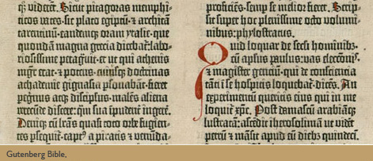
The Humanist types (sometimes referred to as Venetian) appeared during the 1460s and 1470s, and were modelled not on the dark gothic scripts like textura, but on the lighter, more open forms of the Italian humanist writers. The Humanist types were at the same time the first roman types.
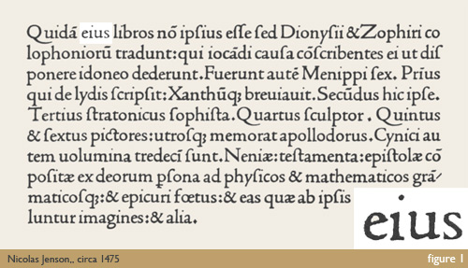

Characteristics
So what makes Humanist, Humanist? What distinguishes it from other styles? What are its main characteristics?
- Sloping cross-bar on the lowercase “e”;
- Relatively small x-height;
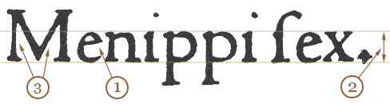
- Low contrast between “thick” and “thin” strokes (basically that means that there is little variation in the stroke width);
- Dark colour (not a reference to colour in the traditional sense, but the overall lightness or darkness of the page). To get a better impression of a page’s colour look at it through half-closed eyes.

Examples
And here are some examples of Humanist faces:
Jenson, Kennerley, Centaur, Stempel Schneidler, Verona, Lutetia, Jersey, Lynton.
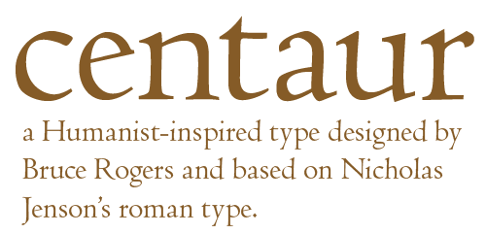
Although the influence of Humanist types is far reaching, they aren’t often seen these days. Despite a brief revival during the early twentieth century, their relatively dark color and small x-heights have fallen out of favor. However, they do deserve our attention — our admiration even — because they are, in a sense, the great grand parents of today’s types.
Grab your passports and pack your toothbrushes because in part two we’re off to Venice to take a closer look at “Old Style” type. For those of you interested in testing your knowledge, can you tell which of the following are not generally considered to be Humanist types:
Erasmus, Times New Roman, Caslon, Cloister, Guardi, ITC Garamond

Further reading:
Wikipedia entry for Blackletter
A Short History of the Printed Word, chapter 4 — Chappell and Bringhurst
Type — The Secret History of Letters, chapters 1 and 11 — Simon Loxley

A Brief History of Type: 2. Old Style (Griffo to Caslon)
In the first part of this series, we looked at Humanist typefaces; we considered them in their historical context, and took a closer look at some of their distinguishing features and modern-day revivals. Today we’re moving along the time line and will spend a little time familiarizing ourselves with some wonderful Old Style typefaces.
Humanist types, we discovered, have strong roots in calligraphy. Old style types, although they owe much to the same roots, show a marked departure from simply mimicking the handwriting of earlier Italian scholars and scribes. It’s from this period, that we can really see type getting into gear. It’s certainly one of the most exciting periods in type history.
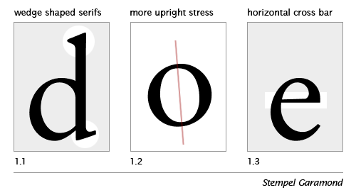

Old Style traits
The Old Style (or Garalde) types start to demonstrate a greater refinement—to a large extent augmented by the steadily improving skills of punchcutters. As a consequence the Old Style types are characterised by greater contrast between thick and thin strokes, and are generally speaking, sharper in appearance, more refined. You can see this, perhaps most notably in the serifs: in Old Style types the serifs on the ascenders are more wedge shaped (figure1.1).
Another major change can be seen in the stress of the letterforms (figure 1.2) to a more perpendicular (upright) position. You may remember our old friend, the lowercase e of the Humanist (Venetian) types, with its distinctive oblique (sloping) crossbar; with Old Style types we witness the quite sudden adoption of a horizontal crossbar (figure 1.3). I spent quite a time trying to discover why the lowercase e should change so dramatically. After searching high and low, and opening just about every type book I own, I decided to post the question on Typophile. Space doesn’t permit to recount the entire tale here, but for those interested in such details, then head on over to the Typophile e crossbar thread. (Thanks to Nick Shinn, David et. al. for their valuable input).

The First Italic Type
And, as we’re on the topic of dramatic changes, during this period we see the very first italic type in 1501. They were first created, not as an accompaniment to the roman, but as a standalone typeface designed for small format or pocket books, where space demanded a more condensed type. The first italic type, then, was conceived as a text face.
Griffo’s contribution to roman type include an improved balance between capitals and lowercase, achieved by cutting the capitals slightly shorter than ascending letters such as b and d, and by slightly reducing the stroke weight of the capitals.
—A Short History of the Printed Word, Chappell and Bringhurst, page 92
The Old Style types can be further divided into four categories as in the figure below, and span the roman types from Francesco Griffo to William Caslon I. Unlike the relatively short-lived Humanist faces, the Old Style faces held sway for more than two centuries; a number of them are still popular text faces today.
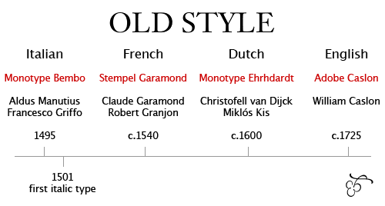
Typeface names in red; notable figures below.

Old Style faces
And here are some more Old Style faces: Berling, Calisto, Goudy Old Style, Granjon, Janson, Palatino, Perpetua, Plantin, Sabon and Weiss, to name but a few.
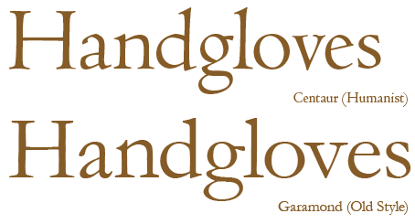
So have you enjoyed our brief introduction to the Old Style types? For those of you who would like to test your knowledge, which of these is generally classified as Old Style:
Times New Roman, Baskerville, Concorde, ITC Cheltenham
And, for the type-masochists among you (I fear you are in the majority), here is some Old Style homework:
1. Where does the term Garalde originate?
2. Who commissioned Claude Garamond to cut the grecs du roi?
3. Most modern-day italics are not based on the first Aldine italic (1501) cut by Griffo. What are they modelled on?
4. What is the meaning of the term “Humanist axis”?
5. Owing to a bit of a mix-up, the Janson typeface is named after Nicholas Janson. Who should it be named after?
If you know the answers, then comment away; if you don’t have a clue, then no need to worry. I thought that by posing these questions, everyone could get involved, and that way we can all learn something.
In part three, we’ll take a look at Transitional typefaces. I hope that you’re enjoying the series, thus far. If you have any comments or suggestions, then get typing in the comments section below.
I’ll be in the UK for the next couple of weeks, so won’t be posting so often. However, upon my return we’ll be back to normal. There’s a whole lot more type lovin’ to come, so stay tuned.
Read Part Three: Transitional Style

A Brief History of Type: 3. Transitional (Siècle des Lumières)
Welcome to part three of our Type Terms series. In part one we traveled all the way back to the 15th century to take a closer look at the Humanist or Venetian style types with their distinctive lowercase ‘e’ (remember that sloping crossbar?). In part two we considered the Old Style or Garalde types and also discovered how this era gave birth to the first italic type in 1501.
Today we’ve moved along the time-line to the cusp of the 18th century, the start of a period in history that we now refer to as the The Enlightenment, a time that was to sow the seeds of revolution in France, North America and beyond. But today we stand in the cobbled streets of 17th century France; Louis XIV is on the throne and Jacques Jaugeon is working on what is now considered to be the first Transitional (or Neoclassical) style typeface, the Romain du Roi or King’s Roman, commissioned by Louis XIV for the Imprimerie Royale in 1692.
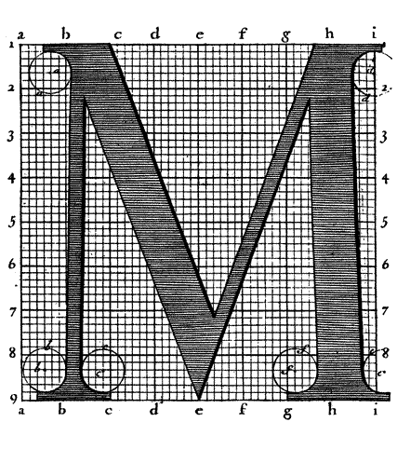
The Romain du Roi marked a significant departure from the former Old Style types and was much less influenced by handwritten letterforms. Remember, this is the Age of the Enlightenment, marked by resistance to tradition, whether that be art, literature, philosophy, religion, whatever; so it’s no surprise that this same era should give birth to radically different types.
The Romain du Roi is often referred to as Grandjean’s type, but the designs were produced by a committee* set up by the French Academy of Science. One of the committee members, Jacques Jaugeon — at that time better known as a maker of educational board games — in consultation with other members, produced the designs constructed on a 48×48 grid (2,304 squares). The designs — also known as the Paris Scientific Type — were engraved on copper by Louis Simmoneau, and then handed to the punchcutter Grandjean (not to be confused with the earlier Granjon of course), who began cutting the type in 1698. Interestingly, Jaugeon also designed a complimentary sloping roman (often referred to today as an oblique) as an alternative to a true italic**. However, Grandjean himself was to produce the italic from his own designs.
The principal graphic novelty in the ‘Romain du Roi’ is the serif. Its horizontal and unbracketed structure symbolizes a complete break with the humanist calligraphic tradition. Also, the main strokes are thicker and the sub-strokes thinner…. — Letter Forms, page 23, Stanley Morison
The first book to use these types wasn’t published until a decade later in 1702. In fact the full set of 82 fonts wasn’t completed until half a century later in 1745.

Baskerville of the Types
The Englishman John Baskervile is a fascinating character, and reading about him is like reading the biography of two men in one. Space doesn’t permit to list all of his achievements; suffice to say that he always strove to improve upon existing methods and materials, whether that be in his recipes for new inks, or his finer quality glossy papers.
[Baskerville] was not an inventor but a perfector….He concentrated on spacing. He achieved amplitude not merely by handsome measurement but by letting in the light.–Type, the Secret History of Letters, Simon Loxley, page 54 (quoting from English Printed Books)
“Baskerville has less calligraphic flow than most earlier typefaces”***, and this can be said of just about all the Transitional Style types. Whereas the earlier Humanist and Old Style types owed much to the handwritten letter form, the pen’s influence has all but disappeared in the Transitional types. The following is a detail from one of Baskerville’s type specimens:
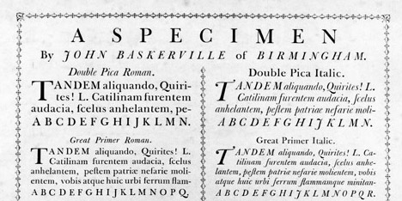
During Baskerville’s lifetime his types had little influence in his home country. However, In 1758 Baskerville met Benjamin Franklin who returned to the US with some of Baskervilles’s type, popularising it through its adoption as one of the standard typefaces employed in federal government publishing. Franklin was a huge fan of Baskerville’s work, and in a letter to Baskerville (1760) he enthusiastically defends Baskerville’s types, recounting a discussion he had with an English gentleman who claimed that Baskerville’s ‘ultra-thin’ serifs and narrow strokes would blind its readers.
Franklin mischievously tore off the top of a Caslon specimen (to remove any mention of Caslon, of course), and showed it to the gentleman, claiming that it was the work of Baskerville. The gentleman examined the specimen, and thinking that it was indeed a Baskerville specimen, started to point out the worst features of ‘Baskeville’s’ type.
Another notable character from this period in type history is Pierre Simon Fournier who developed the ‘point’ system (Fournier Scale), and also designed and cut his own type. William Caslon is yet another notable figure, though his types were based on the Dutch Old Style; however, some modern interpretations of Caslon’s types would sit more comfortably in Transitional.
Whereas Caslon’s letters are thoroughly Baroque, Baskerville’s are thoroughly Neoclassical.—A Short History of the Printed Word.

Characteristics
1 Vertical or almost vertical stress in the bowls of lowercase letters. (See also A Short History of the Printed Word, Chappell & Bringhurst, pages 160-161):
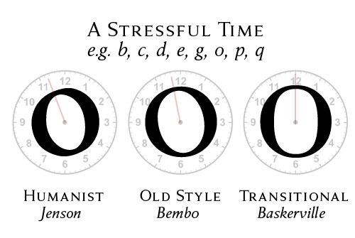
If you read parts one and two, you may well have noticed a trend here: with the stress, like the minute-hand moving from the humanist axis to rationalist axis at 12 o’clock. (Tip: if you’re trying to approximate the angle of stress, pick the lowercase ‘o’ and draw a line through the two thinnest sections [the actual stress is the fattest parts of the stroke]).
2 greater contrast between thick and thin (sub-) strokes:
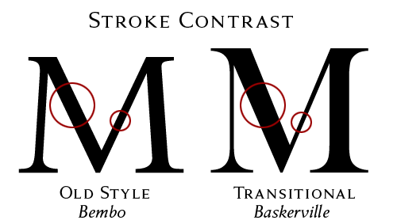
3 Head serifs generally more horizontal:
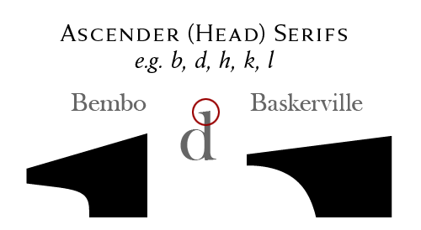
It’s worth noting that the above characteristics are guides only. Modern-day revivals of these types vary in their ‘authenticity’.

Examples
Baskerville (many flavours), Bookman (Linotype), Cheltenham (ITC), Clearface (ITC), Fournier, Joanna, Slimbach (ITC)
And in a brief Back to the Future moment, here’s Baskerville in the 21st century, seen here in the retailer Habitat’s logo (set in Fry’s Baskerville):
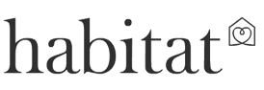

Exercise
Spot the odd ones out. Three of the following are not generally considered to be Transitional style types. Which ones are imposters?
(a) ITC Zapf International | (b) Sabon | (c) Times Europa | (d) Melior
(e) Bodoni | (f) Caledonia | (g) Old Style 7 (Linotype)
Remember, the screen is one place to compare type, but not the best place. Why not take an Old Style type like Bembo and a Transitional like Baskerville and print some of the letters as large as you can—one per single A4 sheet of paper. Also print out some sample body text in each typeface, say, at 9 or 10 point, to determine differences in the colour of the type (the relative darkness or lightness of the type when viewed en masse).
There is so much more to be said about this period in type history, but if you have to scroll any further, your mouse wheel will probably seize. The expanded version of this and all the other articles in this Type Terms/Type History series will be available for download as a PDF (approximately 60 pages).
In part four we’re going to look at the Modern types.
Read part one | two | three | four | five
Footnotes:
* Under the presidency of the Abbé Bignon. The table of the proportions of the letters was drawn up by Truchet. Page 25 of Stanley Morison’s Letter Forms.
** An italic does not need to be ‘sloped’ or inclined to be an italic; in fact an italic type can be upright (and some of the early italics were).
*** from The Elements of Typographic Style, page 56, Robert Bringhurst
Related Links:
Chappell, Warren & Robert Bringhurst. A Short History of the Printed Word. 2nd ed. 1999.
Loxley, Simon. Type: The Secret History of Letters. 2004.
Morison, Stanley. Letter Forms: Typographic & Scriptorial. 1968.
Tracy, Walter. Letters of Credit: A View of Type Design. 1986.
Typophile forum: John Baskerville.

A Brief History of Type: 4. Modern (Didone)
In the previous installment of this series, we took a closer look at Transitional style typefaces, so-called because they mark a transition from the former Old Style types—epitomized by Baskerville—and the subject of today’s brief history, the Moderns, also known as Didone (the terms Modern and Didone are used synonymously throughout this article).
Baskerville’s types, compared with their Old Style (or Garalde) predecessors, are marked by high contrast between thick and thin strokes, so much so that one commentator declared Baskerville was “blinding the nation.” The Moderns or Didones take this contrast to further extremes (just about as far as one can take them).
The first Modern typeface is attributed to Frenchman Firmin Didot (son of François-Ambroise Didot), and first graced the printed page in 1784. His types were soon followed by the archetypal Didone from Bodoni. The Italian type designer, punchcutter and printer Giambattista Bodoni (what a great name! [1740-1813]) drew his influence from the Romains du Roi (with its flat, unbracketed serifs) and the types of John Baskerville (high contrast), for whom he showed great admiration.
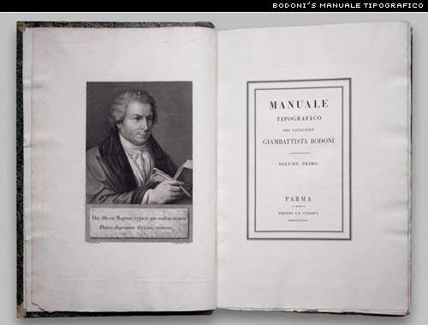
Bodoni will forever be associated with the hordes of digital interpretations from just about every type foundry on earth—the FontBook devotes some 14 pages to flavors of Bodoni; some are faithful digital renderings, others well-crafted interpretations; while others still are nothing but parodies, suitable only for poster headlines or the typographic scrap-heap. However, Bodoni was a prolific type designer, completing hundreds of typefaces; the Museo Bodoniano in Parma, houses more than 25,000 of his punches! Bodoni’s Manuale Tipografico¹ (1818) contains 142 roman typefaces and their corresponding italics—and that’s just volume one. The second volume includes numerous ornaments, Arabic, Greek, Russian, and Tibetan types, to name but a few.

Characteristics
1. High and abrupt contrast between thick and thin strokes;
2. Abrupt (unbracketed) hairline (thin) serifs
3. Vertical axis
4. Horizontal stress
5. Small aperture
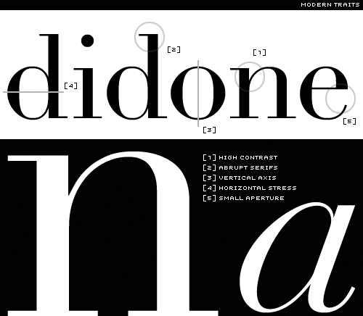
In fact, if you grab a Baskerville, take away the brackets that join serifs to stems, thicken up the vertical strokes, you’ll be left with something that resembles a Didone (though don’t expect it to be pretty).
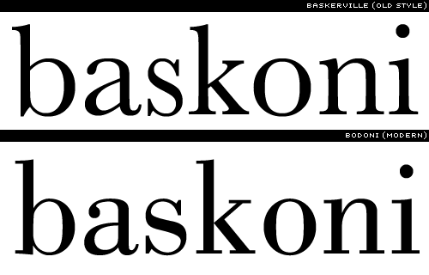
If you’ve read the preceding three installments, then you will have noticed a move away from the Humanist or handwritten letterforms. The romans of the Modern types owe very little, if anything to the earlier calligraphic forms; they are too precise, too sharp, too clean. Whereas the Old Style types are Neoclassical, the Didones are Romantic. Though both forms share a common vertical (rationalist) axis, the Moderns have even greater contrast.

What are they good for?
There’s something rather clinical about the Moderns, especially in the roman capitals. Their vertical axis coupled with strong horizontal stress furnishes them with the stiffness of toy soldiers on parade. They are elegant, and like all things elegant, look unhurried, calm, and in control. They’re generally not suited to setting extended text, as the verticality of the letter forms interferes with the text’s horizontal rhythm. The letters don’t lead our eyes across the page, but rather up and down. Unsurprisingly, Bringhurst brings some clarity to the subject when he writes,
Romantic letters can be extraordinarily beautiful, but they lack the flowing and steady rhythm of the Renaissance forms. It is that rhythm which invites the reader to enter the text and read. The statuesque forms of Romantic letters invite the reader to stand outside and look at the letters instead.²
The Moderns need lots of space (white space and inter-line space), so give them extra leading and generous margins; and if you pair a Modern with another face, then make sure it’s not a fussy one, or your page will look like a circus poster designed by a visually impaired dog. If you know the beautiful, yet austere architecture of Tadao Ando, then mixing a Didot with, say a Blackletter is akin to draping one of Ando’s monoliths in a giant lace doily.
Erik Spiekermann, in Stop Stealing Sheep, recommends ITC Bodoni as “much better at small sizes than all the others.”³

Modern-day Moderns
Open just about any fashion magazine, and you’ll spot a Didone. If it’s a premium brand (read “very expensive”), then it may well be brought to you on the back of Bodoni or Didot. Not being a subscriber to any fashion titles (you’d understand if you saw my wardrobe), I took a trip to my local café and snapped about 100 examples of Modern types. Here are just a few:
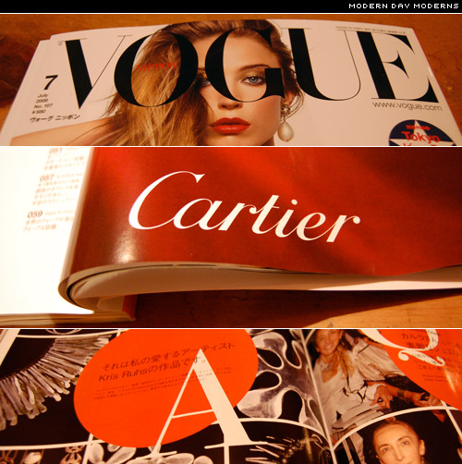
And of the many modern interpretations, these are three of my favourites. The beautifully crafted Didot from Jonathan Hoefler,
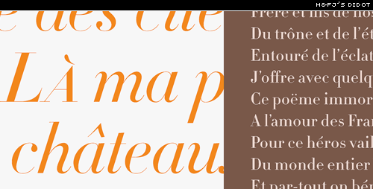
Ambroise from Jean François Porchez (also used to set today’s masthead),
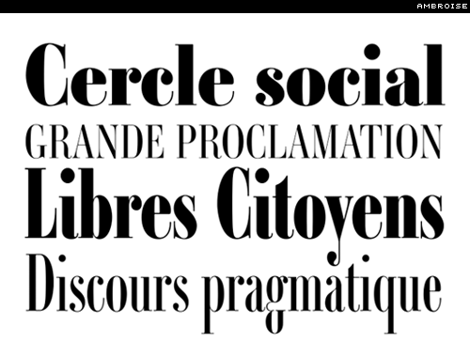
and Moderno FB,
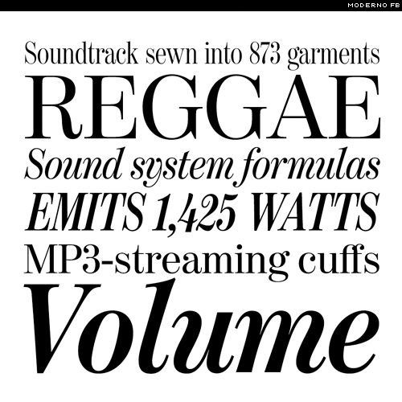
Here are four Didone m‘s compared:
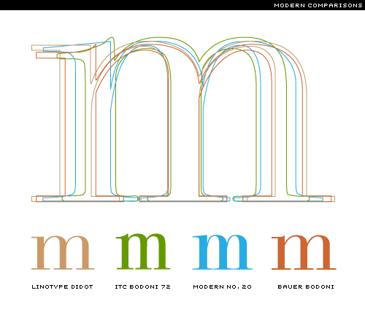
And here are some other notable Moderns: ITC Fenice (I’m not a fan of this one), ITC Zapf Book, Adobe New Caledonia (actually pretty good for extended text), ITC Bodoni*, and Günter Gerhard Lange’s Berthold Walbaum (a little wider set than your average Didone).
Well, I’ve only just scratched the surface, but I hope that this has given you a taste of the Moderns. In part five, the serif pendulum swings to the opposite extreme when we consider Slab Serifs.
Footnotes:
1 You can see the entire book online at Rare Book Room.
2 The Elements of Typographic Style, page 130.
3 Stop Stealing Sheep & Find Out How Type Works, page 83.
* See The Typographic Revolution—Porchez Typofonderie.
I have renamed this series “A brief History of Type”. I think it better suits the thrust of these articles.

A Brief History of Type: 5. Slab Serif / Egyptian
Welcome to the early 1800s and the birth of the Slab Serif, otherwise known as Egyptian, Square Serif, Mechanical or Mécanes. What’s with the name Egyptian? Upon Napoleon’s return from a three year Egyptian expedition and publication in 1809 of Description de l’Égypt, Egypt was all the rage, and it appears that type founders simply used a term that was on everyone’s lips, a term that was in vogue. The nomenclature has absolutely nothing to do with Egyptian Hieroglyph Slab Serifs—because there’s no such thing.
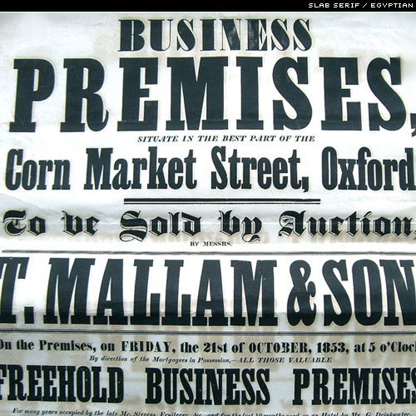
Like the industrial revolution, the Slab Serif was born in Britain, and was no doubt inspired by a new wave of advertising, and those beefy letter forms that could be found on just about every billboard, pamphlet, and poster of the day. Until this time, type was designed to serve one purpose—it was designed for long stretches of texts, for books. But with mechanisation, and major innovations in printing technology (e.g. the Steam Press, 1814), advertisers in particular were looking for a type that stood out from crowd; a type that shouted, look at me! Thus was born the the display face—type for use at large sizes, for short bursts of copy.
…there is sometimes a lack of understanding of the fundamental difference between types designed for display and types meant for text. The difference can be expressed as a maxim: text types when enlarged can be used for headings; display types, if reduced, cannot be used for text setting.—Walter Tracy**
Those posters were a riot of big type, often a half-dozen different styles on a single page. If the Didones are a lissom Audrey Hepburn, then the Slab Serifs are those guys one sees all too often on construction sites around the globe—trousers half-way down their posteriors. What I’m getting at is that the early Slab Serifs weren’t discreet. They were designed to be noticed.
The Slab Serif or Egyptian is also home to further subsets of typeface styles, like the Fat Faces which are fundamentally Didones (or Moderns) on steroids. Take a Modern style typeface, give its thicker strokes even more weight, triangulate some of those serifs, and you have a Fat Face. You might be familiar with types like Poster Bodoni. Bodoni is of course a Modern style type but, carrying all that extra weight, it’s a Fat Face. The Fat Face, then, is basically an Obese Didone.
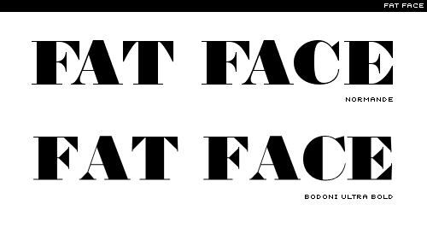
If, as some commentators remarked, the Didones were parodies of Baskerville‘s types, then the Fat Face types are parodies of parodies. The first Fat Face was designed by Robert Thorne (c. 1800), who was also responsible for coining the term Egyptian to describe what is generally known today as the Slab Serif.*
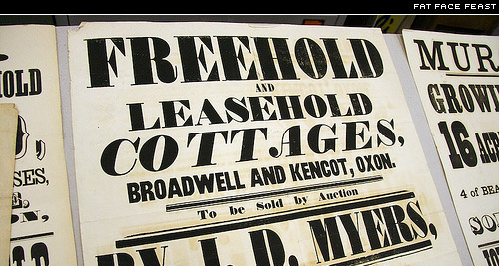
By the mid-1800s, another sub-set of the Slab Serif class of types began to emerge—the Clarendons. They were an attempt to reign in some of the extravagences of the Fat Face display types, making them fit for use as text faces. Contrast was reduced, the serifs thinned somewhat and up with the x-height for legibility at those smaller sizes.
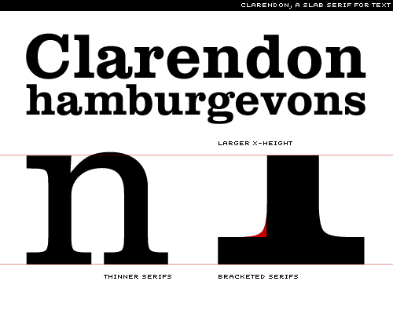
Strictly speaking an ‘authentic’ slab serif has unbracketed serifs (an abrupt serif that meets the stem at a 90° angle), though there are numerous examples that come with bracketed serifs. Then, of course, come the Geometric Slab Serifs that look like the early Sans Serif types with the serifs broken off.
The Geometric is a twentieth-century riposte to the Antique. Informed by the same kind of rationalist thinking that inspired the great sans serifs of the Bauhaus, Geometrics abandon traditional forms in favor of mathematical strategies.—Jonathan Hoefler

The Slab Serif Today
There are thousands of slab serif types available today; some are simply digitised oldies; others are sans serifs and geometric sans serifs with slab serifs stuck on; others still, rise above the crowd and bring something fresh to this style of type.
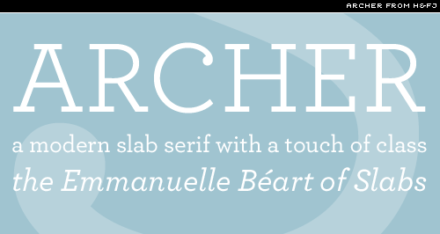
Archer from H&FJ is perhaps one of the best slab serifs for setting extended text. It comes in numerous weights, has an excellent italic accompaniment, and just looks damn good. And, of course, the heavier weights and caps work beautifully for display.
One of my other favourite slab serifs is Erik Spiekermann’s Officina Serif, a very robust, very legible type that just doesn’t break—you could print it on toilet paper, and it would still look good (no, I haven’t tried). If you don’t have Officina Sans and Officina Serif in your type library (or you have a stolen version), then I strongly recommend you purchase a license—it’s a simple type that will never let you down.

Typewriter Types
Just about every typewriter face is a Slab Serif. There are hundreds to choose from, from Courier to ITC American Typewriter immortalised in Milton Glaser’s I ‘Heart’ New York logo.
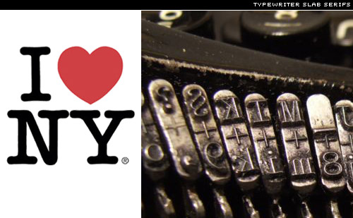
The heavy-weight, no-nonsense serifs of the typewriter types are well-suited to this particular form of printing, and perform well on even the poorest quality paper.
We’ve taken just a very brief look at the Slab Serif. Upon completion of this series, a more comprehensive version will be included in the free PDF.
So what do you think of the slab serif? Do you have your personal favourites? In part six of A Brief History of Type we move on to the Sans Serifs, so stay tuned.
Footnotes:
* To confuse things, the Slab Serif types were initially called Antique; confusing—now—because, Sans Serifs are also referred to as Antique. See pages 80-81 of Walter Tracy’s Letters of Credit—a view of type design.
**Ibid., page 27

Extreme Type Terminology: 1. The Detection of Types
The detection of types is one of the most elementary branches of knowledge to the special expert in crime.–The Hound of the Baskervilles, 1902.
Our modern English alphabet is a child of the Latin alphabet or Roman alphabet, which evolved from a western version of the Greek alphabet approximately 2,700 years ago. The profession of typography was essentially born in Germany with Johannes Gutenberg’s invention of a movable metal type printing press in the early 1450s. The individual pieces of metal type that Gutenberg worked with were not letters, but letterforms.
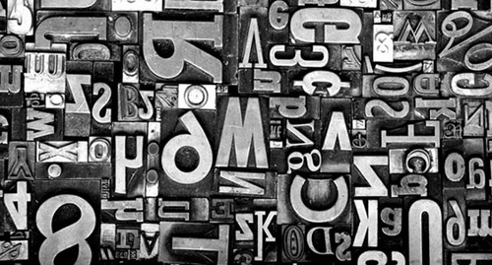
Let me explain. There is a subtle but important difference in meaning between a grapheme, character or letter and a glyph, letterform or sort. A letter, character or grapheme refers to a fundamental conceptual mark that represents a spoken sound. (A phoneme refers directly to the sound.) A sort, letterform or glyph refers to a particular manifestation of a letter or character, one created by a type designer.
A ligature is a single sort in which two or more letters are joined, usually to improve the space between them. There are a few ligatures that are still seen today, such as the connected fi, fl, the triple play ffl, and sometimes even the stylish ct ligature. A typographic diphthong is a glyph of two vowels spliced together, and it symbolizes a phonemic diphthong, two linked vowel sounds. Ligatures and diphthongs are also known as tied characters, tied letters, and sometimes quaints.
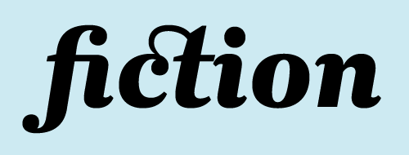
The first typefaces were based on the manuscript handwriting of the time, and were intended to be indistinguishable from it. Typefounders, designers and producers of metal type, have subsequently reached to the Roman lettering of antiquity for inspiration, and now, in an era of digital typography, inspiration and references come from sources that were unimaginable in the past.
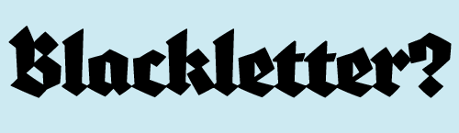
Since the invention of printing, typefaces have been classified historically. The earliest type is now known as black letter, blackletter, block, fraktur, gothic or old English. The humanist, or Venetian typefaces followed, a style that more closely resembled handwriting. Old style, old face, or garalde type. Garalde, a term rarely used now, is a mash-up of the names Garamond and Aldus, referring to the notable typefounders Claude Garamond and Aldus Manutius. Old style typefaces are distinguishable from humanist types by the horizontal rather than oblique or sloping crossbar of the lowercase e.
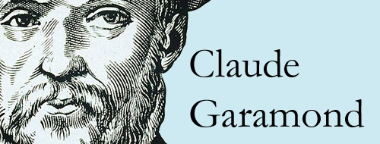
Italic type is an old style variation developed in Venice around the year 1500 at Aldus Manutius’ foundry. It was cut by Francesco Griffo, and based on handwriting of the time. The dramatically condensed characters decreased the space taken up by the text, and with italic type Manutius produced the first pocket-sized books set in this new italic. The first cursive type also arrived around this time. Like italic, cursive resembles handwriting, but cursive characters are, whenever possible, connected.
Transitional type refers to typefaces such Baskerville, by English printer John Baskerville, and Philippe Grandjean’s Romain du Roi, which was created for the exclusive use of presses allied with the French Crown and then declared the only legal typeface. Transitional typefaces have more vertical stress than old style type, they stand taller, with slighter more contrast between the thick and thin strokes, and feature, not insignificantly, horizontal serifs. Transitional type, named in hindsight, was part of an evolution towards the typefaces of the late 1700s and early 1800s.
New face, modern face, or modern typefaces seemed to appear quite suddenly. Modern type has a very nearly vertical and horizontal structure and much greater contrast between thicks and thins than had ever been seen before. Bodoni and Didot, two representative examples, were created by and named for competing family type foundries. Both of these typefaces are also classified as Didones.
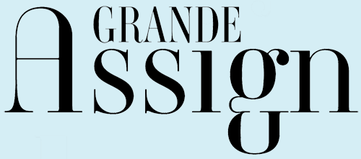
Slab serif and sans serif typefaces appeared in the early 1800s, the 18-teens to be precise. Both are characterized by a fairly even line weight, even into the serifs of the appropriately named slab serifs. The earliest slab serifs were heavy display faces, but these soon evolved into a broad range of weights and styles. Interestingly, sans serifs, easily distinguished now by their lack of serifs, at first resembled nothing so much as a slab serif.
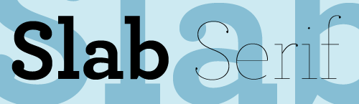
There are other terms that describe not the history but the physical structure of a typeface. The width of a typeface can be described as broad, extended, expanded, normal, condensed, extra-condensed and slim. The posture of a typeface refers to its relationship to an imaginary vertical line. The vertically oriented letters are generally known as roman. Carefully crafted letters that resemble handwriting and lean to the right are generally called italic. Characters that have been mechanically or digitally redrawn to lean to the right–even sometimes to the left–are known as oblique characters.
Case alphabets, such as English, are those alphabet systems in which the letters have two distinct forms. The terms uppercase and lowercase come directly from the slim but heavy horizontal cases of metal type that were indispensable to printers for over 500 years, from 1454 to the 1950s and ’60s. When arranged for the process of handsetting type, the uppercase letters, also known as capitals, majuscules or versals were stored in the upper type case, above and resting at a slightly steeper angle than a second case of letters, the lowercase letters, also known as small letters, or minuscules. The term titlecase refers to the convention, often used in titles and headlines, of an uppercase initial letter followed by lowercase letters in each word.
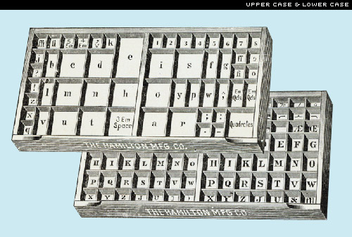
Case mapping is the designation of uppercase, lowercase or titlecase in the editorial or typographic instructions. When specifying uppercase or lowercase type, designers and printers often use the abbreviations Uc for uppercase and lc for lowercase. When used in combination, the use of upper- and lowercase type is abbreviated U&lc or U/lc, and I have heard second hand of a C&lc, an acronym for, presumably, caps and lowercase.
The expression “mind your p’s and q’s” probably comes to us from the tedious and exacting job of sorting metal letters after printing a page and returning them to the type cases. The raised letter on a block of metal type represents a letter that prints in the opposite direction, so a metal p resembles a printed q and vice versa. P’s and q’s were particularly tricky.

Extreme Type Terminology: 2. Anatomy of a Letterform
“I was killing time and pain at a nearby bar called The Ear, so named because the two ribs of the ‘B’ in the neon sign that read ‘Bar’ had burned out years ago. So had most of the patrons.”—Kinky Friedman, Blast From the Past, 1998.
Just as Kinky Friedman anthropomorphizes this B, giving it human characteristics, namely ribs, type designers have come up with some very human terms to describe the details of the letterforms that they create. They speak the arm (of, say, an E), the crotch (of an M), which could further be described as an acute crotch or an obtuse crotch, the ear (of some g’s), which might be a flat ear or a floppy ear, the eye (of an e), the leg (of a k), the shoulder (of an n), the tail (of a j or a Q), and the spine (of an S). There is a sketch by the great type designer Ed Benguiat that labels the curl, the lobe and the ball of a single question mark.
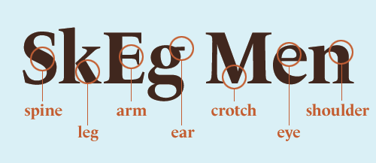
Typically, the point which rests under a question mark or hovers over a lowercase i or a j is called a dot, and the etymology of the word reveals another anthropomorphism: at one time the word dot referred explicitly to the head of a boil or pimple. The dot is also sometimes quaintly referred to as a jot (from the Greek iota) or a tittle (from the Latin titulus).
Nature is recalled in a few terms, such as the stem, the arc of the stem (otherwise known as the shoulder), and the splayed stem. And this is not surprising; an organic sense of life separated the Roman alphabet from the geometric Greek characters that originally inspired it.
Architecturalisms, borrowed from the language of architecture and design, are also common. And why shouldn’t they be? After all, nothing resembles a Roman monument more than the Roman M, especially one with serifs. And the second character in the Phoenician alphabet, beth, which evolved into the Greek beta and the Roman b, comes from the Phoenician word for “house”. Even today, a capital B, if turned counter-clockwise 90°, as the Phoenicians oriented it, resembles a building.
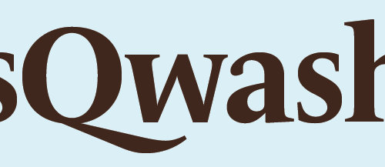
Some of these architecturalisms are the aperture (of a c), apex (of an A), axis or stress (most obvious in an O), the ball (at the bottom of a question mark), the bar, crossbar, or cross beam (of an H), the bowl (of a p or b), counter (of an a or b), flag (a flourished stroke common in black letter type), the hook or finial (of some t’s), inlines (which resemble carved strokes inside the lines), ink traps (notches created to prevent ink bleeds at predictable points on the letter), the joint or juncture (of an R or a Y), the link and the loop (of a g), the spur (of many G’s), the stroke (the main lines of a letter), swash (an exaggerated stroke), swing (the diagonal link of some g’s), and the vertex (of, say, a V).
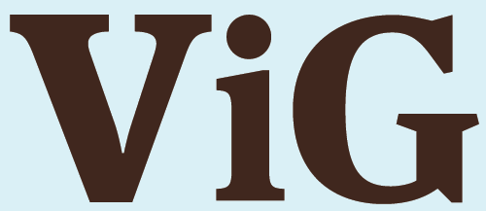
An experienced typophile can also distinguish between, and speak of, a descended or base-lined J, a one-story or a two-story g, a crossed, joined or rounded W, and even a round as opposed to a super ellipse or obround (elongated with straight sections) O. Even as seemingly simple a thing as a terminal, the end of a non-seriffed stroke, can be characterized as an acute terminal, a ball terminal, a beak terminal, concave, convex, flared, hooked, horizontal, lachrymal (or teardrop) painted, rounded, sheared, straight, or a tapered, terminal.
Serifs were forever defined for me as ‘the little feet on the letters’ by my first type teacher, P. Lyn Middleton. The classification of the innumerable variations in type design that exist today begins with the existence or non-existence of these little feet, which have existed as a crucial detail on most Roman letterforms for a little over 2000 years. Curiously the word itself has a short history. It was probably a back formation from the word sans-serif, which first appears in print in 1830, when typefounder (a designer and producer of metal types) Vincent Figgins published his Specimens of Printing Type. Sans, a French word forever, has been an English word since Middle English times:
“. . . Last scene of all,
That ends this strange eventful history,
Is second childishness and mere oblivion,
Sans teeth, sans eyes, sans taste, sans everything.”
—William Shakespeare, As You Like It, 1599 or early 1600.
The French sounding serif may have come from the Dutch schreef, “a line” or “a stroke”, from schrijven “to write”, and from the Latin scribere. Type without serifs occurred in Roman times, but it was rare and is seldom seen. In the early nineteenth century sans serif typefaces re-emerged, perhaps as an evolutionary branch away from the Egyptian or slab-serif fonts that were popular at the time. (The fat slab serifs may have become so ungainly that someone at a type foundry, where new letters were carved from steel, decided to simply and literally chop them off.) At first these new letters were described as grotesque or grotesk types, perhaps because they seemed incomplete and ugly, and these terms are still among those used to describe sans serifs today.
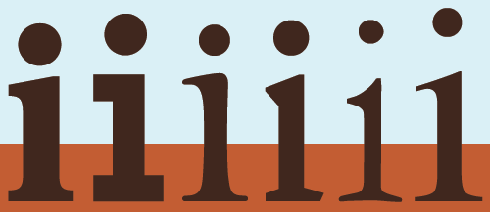
The French, meanwhile, tended to use the word antique to refer to sans-serif type, and this word has found its way into English, in, for example, the typeface name Antique Olive. The word gothic is also sometimes used to describe a sans serif, and the terms Gothic and Doric, with capital letters, are now used to refer to the square-stroked sans serif variations of Japanese characters.
Sans serif type faces vary tremendously, and are further categorized as geometric (for example, Futura), monoline (Akzidenz Grotesk), rounded (Frankfurter), humanist (Gill Sans) and neo grotesque (Helvetica).
Broadly speaking, there are two styles of serifs, unilateral serifs, which break from the stem in only one direction, and the more common bilateral serifs, which break from the stem in two directions. These can be further characterized by a surprising number of terms: type designers speak of abrupt serifs (that break abruptly from the stem at an angle), adnate serifs (which emerge from the stem gradually and more organically), bifircated serifs (which appear to curl away from a split in the stem), bracketed or fillet serifs (with a curved connection between the serif and the stem), cupped serifs (which form a concave curve or ‘suction cup’ at the end of the stem), scutulate serifs (diamond shaped), finial serifs (with a somewhat tapered curved end), foot serifs (which rest firmly on the baseline), hairline serifs (hairline thin foot serifs), slab or Egyptian serifs (thick serifs set at right angles to the stem), square serifs (square-shaped slab serifs), straight serifs (which are thin but not hairline serifs) and wedge serifs (simple wedge-shaped or triangular serifs).

Extreme Type Terminology: 3. The ‘Black Art’
An invisible grid of parallel horizontal lines is used as a constant reference in the creation of a font. It resembles a musical score and its four (or five) horizontal lines represent, from top to bottom, the ascender line (the height of the highest ascender), which is sometimes equivalent to and sometimes higher than the ascent or capline (the height of the capital letters). Next comes the meanline or waist line (the height of a lowercase x), which can be referred to as a high waist line or a low waist line; the baseline (on which the letters appear to rest); and finally, at the very bottom, the descent, descender or beard line (the level to which the lowest descenders descend).
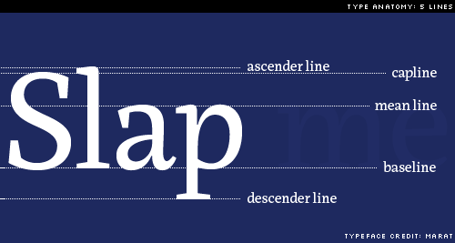
Ascenders are the parts of some lowercase letters that rise above the meanline, and descenders are, conversely, the parts of some lowercase letters that fall below the baseline. The ascenders and descenders of a given typeface may be described as long, normal or short. There are a number of self-descriptive terms for the relative distances between the lines on this typographic grid, such as the p height, the k height, the H height or cap height, and, most famously, the x height or body of a typeface.
The lowercase letters, which, like the x, have no ascenders or descenders, are known as the primary letters. The uppercase or capital letters are the 23 capitalis monumentalis invented by the Romans, plus three characters that were added to the alphabet later: U and W, about a thousand years ago, and just 500 years ago our youngest letter, J was born.
I look for unevenness, for letters that are over- or under-weight, for any inconsistencies that might flag the flavor. Every letter must be independently legible so that if it is seen out of context it will not be misread. Finally the entire alphabet must be ‘in tune’….
The oboe is the first instrument you hear when a symphony orchestra begins to ‘tune up.’ The oboe gives the pitch. It has great penetration and can easily be heard by all the other instruments. Now comes a surprising coincidence: the letters O B E in the word OBOE and the lowercase letters o b e—or preferably o d e—are, by the nature of their design, key letters that give the pitch to which other letters of the alphabet may be tuned. O B E and o d e carry a big load in determining the character of a style. They are not dramatic shapes like a or g or s, but they sound the pitch clearly. First they must be in tune with each other, then the remaining letters should be in design harmony or in artistic balance with these three. All must be in tune.”
—Edward Rondthaler, Life with Letters, as they turned photogenic, 1981.
When creating a new typeface, type designers sometimes look at particularly revealing words to test the look of the letters in sequence. These are known as key words, trial words, test terms, and sometimes simply as proof. The word Slang, for instance, contains an uppercase letter, lowercase letters, an ascender, a descender, round letters and straight letters. The aforementioned Oboe is a key word; some other popular trial words are Champion, Hamburgevons, Hamburgefonts and even, for those who really want to study their emerging typeface, Hamburgefontsiv.
A set of fonts that are designed to appear related, but with contrasting proportions and weights, is known as a family. A type set is a complete set of letters, sometimes, but not always, including both uppercase and lowercase characters and basic punctuation. A type set is also known as a font. An advanced type set, which typically include alternate characters such as swash letters, once very popular in book and movie titles, is known as an expert set. Expert sets often contain alternate characters and small capitals or small caps, are often used for the first few words of an opening paragraph.

Typographic Color
The praises of the discoverer of the ‘black art’ continue to be sung right up to the present time. Mark Twain for instance says that the whole world acknowledges without hesitation that Gutenberg’s discovery was the greatest event known to man.
—Albert Kapr, The Art of Lettering; The History, Anatomy, and Aesthetics of the Roman Letter Forms, 1983.
When typographers mention to color, they are typically not referring to a rainbow. They are speaking, instead, of black and white and the wide range of grey textures which are called forth when white and black interact. Every typeface has its own apparent lightness or darkness, or optical weight. Arranged as they might fall along an imaginary grey scale, some of the terms used to describe a type’s color are, from darkest to lightest: black, ultra bold, extra bold, bold, demi or demi bold, medium, book, lightface, and hairline. As the great Swiss typographer Emil Ruder put it in 1960, “The business of typography is a continual weighing up of white and black, which requires a thorough knowledge of the laws governing optical values.”
According to tradition, the ideal typographic color for a block of text is an even grey that can be better seen when you slightly squint your eyes at a page of type. Rivers are vertical ribbons of white space that sometimes appear by happenstance in a column of type. To the most sensitive typographers, rivers are like fingernails on a blackboard. They are most common in newspapers, which tend to have narrow columns and tight deadlines. The problem with rivers is that they draw your attention away from the text that you were trying to read.
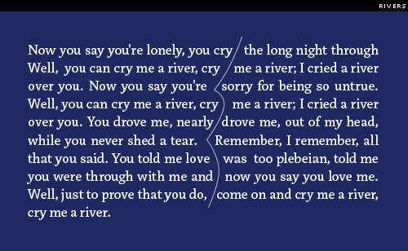
A bad break refers to an awkward typographic situation which might distract a reader from a typeset text. Typographers take bad breaks very seriously and have given them appropriately tragic names. A widow occurs when a short word at the end of a paragraph is left alone on a single line, thus awkwardly breaking the column of type. When this lone word occurs at the top of the next column, the poor thing is called an orphan. Typographers and graphic designers blithely toss some other startling words, referring to the bleed (images or text which run off the edge of a page), a full bleed (a bleed on all four sides of a page), and the often gleefully spoken kill, which denotes the power to delete unwanted copy from the design.

White Space
Among graphic designers and typographers there is an extensive vocabulary for describing white space or negative space, the unprinted area of a printed piece. This terminology includes the margin (the space around a column of text), which might be a head margin (above the text), a foot margin (below the text), a side margin (towards the edge of a book or magazine), or a gutter or alley (the space toward the page fold, or between columns of text). Reversed type or knock-out type is type that is not actually printed, but is revealed, in the color of the printed surface, by the ink that surrounds it. Open matter refers to text, such as pull-out quotes (also known as lead-ins, extracts, or callouts) that is set with abundant linespacing or many short lines.
The white space between lines of text type is known as leading, and is quantifiable in points. The term comes from the strips of soft metal, which were once placed snugly between rows of metal type. These strips of leading were lower than the type itself, and so did not print. Today leading is also referred to as linespacing, interline spacing, linefeed, or interlinear space (a term preferred by many authors). Lines of type with no leading are said to be set solid. These days, leading refers to the distance between baselines. Negative linespacing or reverse leading is now possible with digital type, but is never good for extended text, as the ascenders and descenders collide.
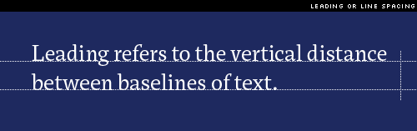
Every typographer knows that it is the space around and between the letters that defines the letters. This interletter spacing, letter spacing, letterspacing or tracking, as it is variously known, can be described as loose, normal, tight, very tight, kissing (the super-tight spacing popular in the 1970s), touching, and there is even a term for the step beyond: negative letterspacing.
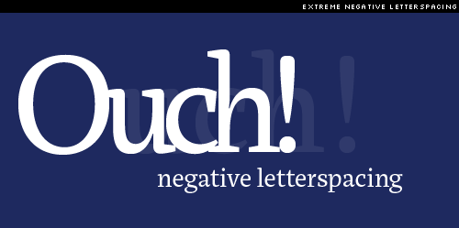
When characters that should not touch each other, do, this is known as a crash. When the space between pairs of letters is fine tuned by the typesetter, this is known as kerning. Kerning includes the adjustment of space known as white space reduction, which is also known as dovetailing, notching or undercutting. But kerning can also refer to an expansion of space, as when kerning to correct a crash.
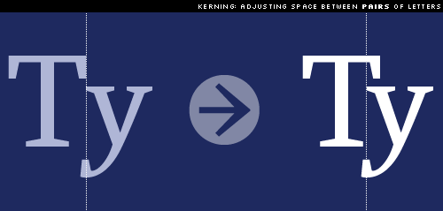
The space between words is known as interword separation, interword spacing, word spacing or wordspacing, and can be described as loose, normal or tight. There are also specific blank spaces that relate to the size of the type. The em space, mutton or mutton quad is the width of a capital M, the en space, also known as half an em or a nut, is half that width.
In the days of metal type, the em space and en space were supplemented by even smaller spaces, such as the 3-em or 3-to-the-em space, a third of the width of an em space, the 4-em or midspace, one quarter of the width of an em space, and the 5-em space, or 5-to-the-em space, one fifth of the width of an em space. Nowadays, graphic designers tend to refer to the smaller spaces as, in order of their decreasing widths, a flush space, a thin space and the tiny hair space. Other spaces worth noting are the nonbreaking space, which refuses to be hyphenated, the figure space, the width of a monospaced number, and a punctuation space, the width of the simplest punctuation marks.

Extreme Type Terminology: 4. Numerals and Punctuation
“The very air of the room seemed charmingly alive with little floating dollar signs and fat little ciphers, commas, more ciphers, all winging around happily, waiting for a mere scratch of the pen to call them into action.” — Dawn Powell, Angels on Toast, 1938.
The Roman alphabet came equipped with its own numbering system, and Roman numerals still have their uses. They are commonly seen, for instance, on clock faces, in movie credits, and on the pages of a book which precede the introduction and the text itself. The letters M D C L X V and I, used in combination and sometimes with a bar over the letter, Roman numerals can signify all whole or natural numbers. Well, everything but zero (0). The zero was invented in India, and it has maintained the same form, generally a circle but sometimes just a dot, ever since.
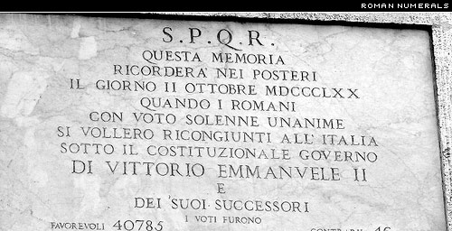
The word cipher, derived from the same root zephyr and zero, usually suggests a zero but it can refer to other digits too. The European digits that have generally come to replace Roman numerals are sometimes referred to, inaccurately, as Arabic numerals. They might more properly be called Indian numerals, because they evolved from characters that, like the zero, originally came from India. The term Arabic numerals can lead to confusion with Arabic digits, the numbering system currently in use in Arabic culture. Arabic numerals and Arabic digits have similar ancestors, share some formal characteristics, and consist of ten characters, but are completely different symbol sets.
Typographically speaking, there are several ways to classify European digits. Tabular figures share a common figure width and are used for tabular data because they form orderly rows and columns. Proportional figures have varying widths and are used for everything that doesn’t require tabular figures.
Old Style or text figures are designed to work in harmony with the ascenders and descenders of a typeface; they sometimes fall below the baseline, and sometimes rise above the x-height. Lining figures are usually drawn to match the base and the height of, and thus align with, capital letters, but some type designers create a second set that is slightly shorter than the capitals and looks better in running text.
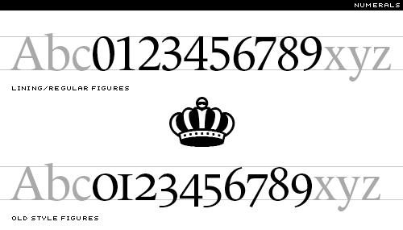
A specialized font might also include numerator and denominator figures. Smaller numbers that rest below or just higher than the regular characters are known inferior or subscript (the lower numbers) and superior or superscript (the higher ones).
The forward slash (/), which we met earlier, is used to create horizontally bound split fractions. Stacked fractions, also known as horizontal bar fractions or vertical fractions, consist of numbers stacked above and below a figure dash. A nut fraction is a stacked fraction that is specifically designed to fit an en space. A built fraction is one that is painstakingly assembled element by element, whereas a piece fraction is one that comes as part of a font.
Speaking of math, the basic typographic units of measurement are the point and the pica. There are 12 points in a pica, and a pica is equivalent to 1/6 inch, thus making a typographic point 4.233 mm or 0.166 inch. Type is typically measured in points, and type size is referred to as point size. (Point size is determined by measuring from the top of the highest ascender to the bottom of the lowest descender, and therefore cannot be accurately measured from a single character.)

Dashes, Rules and Dot Leaders
The smallest typographic line is the hyphen, the short dash used to link hyphenated words and for wordbreaks at the end of a line. Ems and ens return to help describe the other line dashes: the en dash, the width of an en space, and the em dash, a popular line the width of an em space.
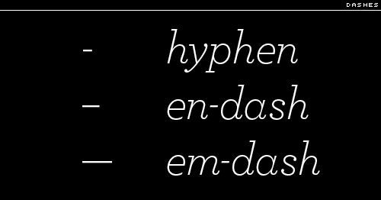
As Alexander & Nicholas Humez, describe it in the book ABC Et Cetera, “The em dash is used to indicate abrupt transitions—What?—and quasi-parenthetical expressions—such as this one.” The two-em dash and the three-em dash are precisely as long as their names imply.
The two remaining character-size lines are the underscore or understrike (_), and the increasingly popular pipe, also known as a vertical or a vertical bar (|). Incidentally, the grids created using vertical bars and understrikes, open at the top, for the filling-in, letter by letter, of information are known as combs.
Larger typographic lines are referred to as rules, which is perhaps not surprising in a field as traditional as typography. A hairline rule is a particular fine line; other rules are defined by width as measured in points. At some undefined point a wide rule becomes a bar. Bar width is also measured in points. Cutoff rules are used to distinguish the width of columns of type, and a leader of dashes sometimes carries the eye across a column of information, linking, for instance, a chapter title to a page number. A dot leader is a row of periods or midpoints set for the same purpose.
The ruled box in the upper right hand corner of an envelope or postcard that contains permit information instead of a stamp is known as the indicia. The left and right hand pages of an open book or magazine spread are known as the verso (the page on the left) and the recto (the page on the right).
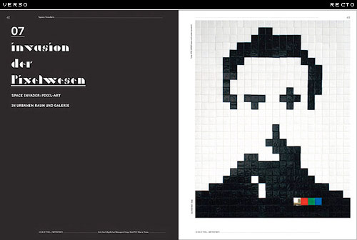
The page numbering is known as the pagination. A page number is also known as the folio. Folio refers to the printed number, not the page itself, and so a page without a page number is known as a blind folio.

Punctuation
There were no extraneous specks, lines or squiggles to distract from the beauty of the original Roman majuscules. There were not even any spaces between the words, and this helped give Roman lettering, particularly when inscribed in stone, a harmonious texture. For sheer aesthetic appeal, legibility be damned, a comparison of wordswithoutspacing and space between the words reveals the beauty of the former and can leave the latter looking like gap teeth.
The first punctuation mark was a dot or small triangle situated midway between the top and bottom of the letters, which was used, instead of spacing, to indicate a named or title. The interpunct, centered dot, middle dot or midpoint has been hailed by Wikipedia, as “perhaps the first consistent visual representation of word boundaries in written language.” So the interpunct may be the mother of all punctuation marks, and not just the obviously similar, but slightly bolder and much lower full point, full stop, or period (.).
Today we would be lost, or at least often confused, if we didn’t clarify our prose with this handy little dot. The period once had an even loftier role in world affairs: most nineteenth-century newspapers had a period at the end of their mastheads. The New York Times continued with the period until 1966, half a century after most other papers had dropped the dot. Perhaps the editors felt that the period suggested stability and tradition, and was therefore worth the $84 a year in ink that type designer Edward Rondthaler once jokingly estimated that it required.
There is more to punctuation than just periods, of course. As every type designer soon realizes, a complete font set will also need an apostrophe (’), colon (:), semicolon (;), comma (,), hyphen (-), an en-dash (–), an em-dash (—), ellipsis or suspension points (…), and an exclamation mark, sometimes known as an exclamation point, screamer or bang (!).
In Britain the exclamation mark is sometimes referred to as a dog’s prick, and that, further, the combination of a colon and a dash (:—), out of fashion now but long used to represent a restful pause, is known as a dog’s bollocks. This is because the combination is, according to the online Oxford English Dictionary, “regarded as forming the shape resembling the male sexual organs.” The “dog’s bollocks (also dog’s ballocks)” also serves, incidentally, as British slang for the best of anything; as in the “bee’s knees.”
The question mark, query or squiggle (?) is of course crucial mark, and there are two types of quotation marks: smart quotes, also known as curly quotes or, in Britain, inverted commas (“”), and prime marks, a catch-all which includes the foot mark (′), the inch mark (″) and hatch marks or dumb quotes (″″). Both smart quotes and dumb quotes can be referred to as single quotes (‘’) or double quotes (“”). Standard punctuation marks also include a set of braces or brackets ([]) and its variations: curly brackets ({}), chevrons (<>), guillemets, otherwise known as angle brackets or angle quotes («»), and, of course, parentheses, which is both singular and plural for the ubiquitous curls (()), which can be distinguished individually as open parentheses (() and close parentheses ()). (Parenthetically, parenthesis, spelled with an i, refers to the inserted material, while parentheses, with three e’s, refers to the typographic glyphs.) And these days every typeface needs a slash or forward slash, also known as a slant, stroke, diagonal, whack, separatrix, or virgule (/). A pair of these, leaning as they do on every page of the Internet, are known as a double virgule (//).
The ampersand (&) is a stylized ligature of e and t, and represents the Latin word et or ‘and.’ Other commonly called for but unusual marks are the asterisk or splat (*), the commercial at sign, more commonly known as the at (@), the backslash (\), bullet (•), caret (^), currency marks (such as ¢, $, €, £, and ¥), a dagger or obelisk (†), double dagger (‡), degree mark (°), an inverted exclamation point (¡) and inverted question mark (¿) for Spanish exclamations and interrogations, a lozenge (◊), a percent sign (%), a paragraph mark, paragraph sign, pilcrow or alinea, from the Latin a linea, meaning “of the line,” (¶), a section sign (§) and what must surely be the most-named typographic mark of all time, an octothorpe (named by Bell Labs’ engineer Don MacPherson by combining octo-, meaning eight, with the name of the 1912 Olympic decathlon champion Jim Thorpe), with the variations octothorp or octothorn, also known as the crosshatch, double hashmark, pound sign, number sign or, in computerese, a crunch (#).
Accent marks, which rest over and under the letters of foreign expressions, are also known as diacritical marks or diacritics. Some common diacritics are the acute or aigu (é), the cedille (ç), the caret, circumflex or circonflexe (ê), the grave (à), the tilde or swung dash (ñ), and the umlaut, a feature in many German words (ü), is identical to the diaeresis or trema (ö) that is rare and not mandatory in English (don’t be naïve), but is a regular feature of Dutch, French and Spanish.
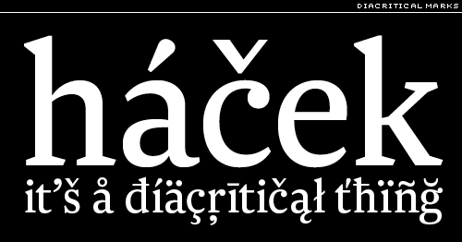
A floating or non-spacing diacritic has, in the computer’s mind, zero width, and so one diacritic can be easily combined with any of a variety of letters.
Dingbats are typographic ornaments or simple illustrations, the most famous set of which, Zapf Dingbats, was designed by Hermann Zapf. They are sometimes also known as ornaments, or as fleurons if the illustrations are of a horticultural nature. A set of pi characters, also known as a pi font, consists of nothing but unusual type forms, generally known as all sorts, special sorts, or peculiars.
Slang punctuation refers to typographic signs that are created by the user of a typeface, rather than the type designer, by combining pre-existing characters of the font. Two examples are a combination of question marks and exclamation marks (!?) to express exasperation, or augmentation by repetition (!!!) for emphasis. A third is a form of expression that has developed as a consequence of the surge of email and text messaging: emoticons, such as the apparently timeless smiley face. =)
In Emoticons During Wartime, a recent article in The New Yorker (December 10, 2007), Tom McNichol documents the usefulness of emoticons in communicating by visual innuendo. Emoticons can mean whatever the writer and reader want them to mean, until, of course the meaning is explicitly defined for all by The New Yorker. Two striking examples are:
“=|:-)= This e-mail is being monitored by Uncle Sam for your protection,” and “:-x I’d rather not say in an e-mail that’s being monitored for my protection.”
“When the world blows up and the final edition has gone to press the proofreaders will quietly gather up all commas, semicolons, hyphens, asterisks, brackets, parenthesis, periods, exclamation marks, etc. and put them in a little box over the editorial chair.”
—Henry Miller, Tropic of Cancer, 1961.

Extreme Type Terminology: 5. Diminuendo, and the Future
A ‘typographic’ tradition since Roman times, diminuendo is a type arrangement in which a large letter or word leads the eye, gradually, to smaller and smaller words until a standard text size is established. An abbreviated diminuendo is still seen today in the initial cap or large single letter that is sometimes used to lead the reader into a chapter of a book or a section of an article.
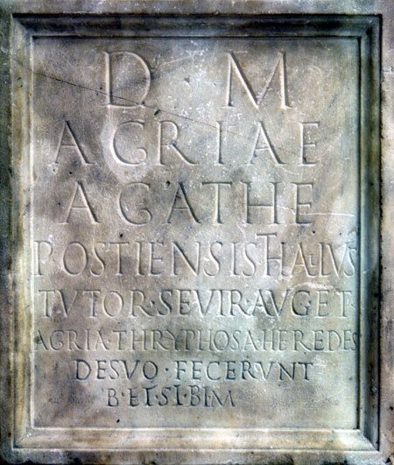
There are three basic variations on this theme: the drop cap, also known as a drop initial or sunken initial, the elevated cap, also known as a raised cap, raised initial, or stickup initial, and the hanging initial or hung initial, which falls outside of a column of type.
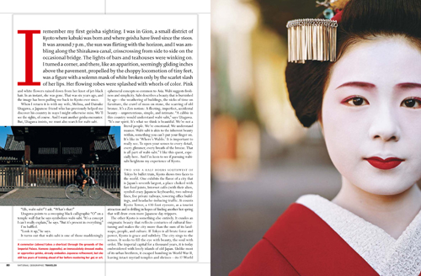
The alignment of type in a column is one of the most basic decisions a typographer faces. The three most common choices are flush left, or quad left, which implies a rag or ragged edge of line endings on the right side of the column; justified type, or quadded type, columns which have perfectly aligned type on both the left and the right; and flush right or quad right, implying a rag left, a ragged column on the left hand side. The rag, by the way, might be a rough rag or a tight rag. In practice, a tight rag is set by allowing for word hyphenations, and a rough rag occurs when word hyphenations are disallowed.
Some other type alignments are centered type, asymmetrical (or random) alignments, stacked type, in which the words or letters are stacked one below the next, bounced type, when the baseline of each individual letter bounces up and then down and even retrograde, type that is reversed in the sense of a reflection in a mirror.
Headlines are a common typographic element with many variations that includes the masthead or nameplate, as of a magazine or newspaper, and of course the standard headline or header, used to draw attention to a text that follows. Subheads commonly follow with secondary information. Some other variations on the headline are the jump head, the small headline above a full headline, and the running head or running header that runs through both books and magazines. A running foot or running footer is near the bottom of page, rather than the top. Sidebars or sideheads are sometimes useful for secondary information, as are the captions that often fall below photographs or illustrations.
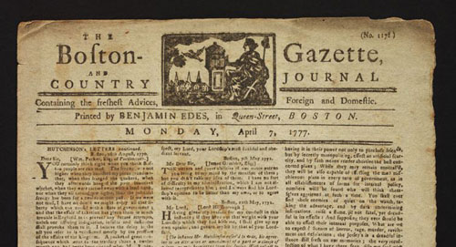
The headline evolved from the capsule-encircled cartouche of ancient Egypt, and is related to the logo or logotype which has come to dominate the modern visual landscape, which now includes typographic logograms, such as OpenType, in which the uppercase and lowercase letters are established, usually to maintain the corporate identity of the wordmark.
The opposite of a headline, the ultimate in humble text, the last information in many books, tucked near the bottom of the last verso (left-hand) page of many books, though sometimes it is near the beginning, is the colophon. The colophon is a paragraph or so of plain text that contains information about the design and production of the book, including the name and sometimes even the history of typeface or typefaces used in the book. Generally there is no headline to distinguish a colophon. It’s just there, humbly awaiting the eyes of those who are interested in these things.
Just as English has a tendency to absorb words from other languages, it is possible that typographers of the future will use terminology from related fields, such as comic books or graphic novels, which are now commonly accepted as literature. We are already well attuned to the meaning of emanata, the straight lines that emanate from a figure’s head in moments of surprise or astonishment, squeans, the centerless asterisks that resemble popping bubbles and suggest an alcoholic delirium, and the boozex, which is, as the name suggests, an X marked on a bottle to suggest booze. Grawlix refers to the sequence of typographic symbols used to represent non-specific ‘cussing’ such as might be spoken by a cartoon character such as Beetle Bailey (#@$%*!). It was, in fact, Beetle Bailey’s cartoonist, Mort Walker, who gave us the term. (He also named a few of the grawlix’s component parts, such as the jarn, a little spiral, the nittle, a crosshatch, and the quimp, a tiny Saturn-like planet.)
The language of graffiti culture, like that of hip-hop culture, with which it is closely allied, is deliberately cryptic. Graffiti is meant to be readable by graffiti artists and enthusiasts, but illegible to the general public. A writer refers to a graffiti artist. A crew is a loosely organized group of writers, who often write the initials of their crew members along with their own name.
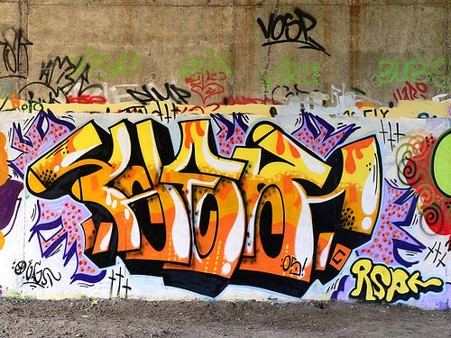
A tag is the most basic form of graffiti, a graffiti writer’s personal signature or logo, drawn in one color. The tag might include a character, which refers not to a letterform, but to an iconic cartoon figure. Tagging is the act of writing the tag with a marker or spray paint. A slightly larger and more ambitious version of the tag is known as a throwie or a throw-up. A typical throwie has a background color and an outline in a second color. The interior color of the letters on a throw-up is known as the fill or fill-in. When the second color is only roughly sketched or lined in, the throwie is known as a scrub. The most ambitious graffiti of all is work that is done on a large scale in at least three colors, often incorporating fades or blended colors. This is known as a piece, short for, of course, a masterpiece.
The plastic cap or tip on a spray paint can determines the line weight. The standard caps that come with spray paint are known as sucker tips, and are often replaced with others, such as skinny tips, thin tips, thick tips, fat tips, or flare tips. The largest fat caps are sometimes known as softballs because of the soft round marks they make. Line width is sometimes described in fingers. A four-finger line is, for instance, about as a wide as a hand. Bubble letters, quite out of fashion now, were an early style of graffiti lettering with a rounded shape, and roller letters are large-scale tags drawn with paint rollers. To bomb an area is to profusely cover it with tags or throw-ups. To kill an area is to bomb it beyond a point of diminishing returns.
The culture of the internet communication and text messaging is changing the alphabet in other other interesting ways. According to the editors at Merriam-Webser, 2007’s Word of the Year was w00t, written with zeros rather than proper Os. The word w00t evolved from two currents: hip-hop slang for delight at seeing a woman’s posterior, and from a computer programmer slang called leet, l33t or l33t sp34k, in which letters are exchanged for numbers and other typographic forms that suggest their shape, and are often playfully juxtaposed to create a gestalt that is visually ambiguous or incomprehensible to outsiders, but perfectly legible to the elite who create and understand it. “Ph342 /\/\j 133+ 5|<1||%,” for instance, translates to insiders as “fear my leet skills.”
As we move into an Internet-intensive future, the word-on-paper will survive, but as the dominant text medium it will fade, as did papyrus, stone and clay before it. The written word will most commonly be consumed from a computer screen (just as it is a computer screen that I am looking at as I write this). But the written word, text, will survive. Written or “printed” words, must have a visual form (with the exception of Braille, perhaps). It is the visual form of words that is of interest to typographers and type designers, not ink or paper. As the medium of “print” continues to shift to the “digital environment,” and as readers begin to take advantage of preferences and the personal options inherent in digital text, the invention and even the enthusiastic acceptance of more typographic variation seems inevitable.
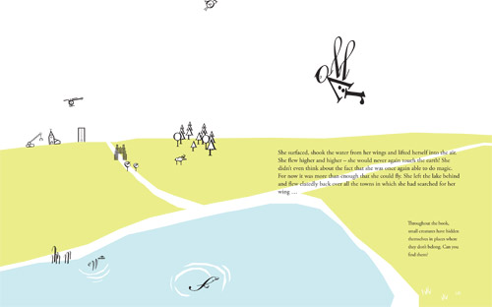
It is worth noting that many of the terms mentioned in this essay are already familiar to the general public. It seems that, especially among young people, an awareness of and interest in typography is on the rise. The form of the English alphabet will continue to evolve; it will swing back to its historic roots, the 23 Roman majuscules, and then again into the future. The terminology of typography will continue to expand, as future generations of young designers think to themselves, as Woody Allen wondered in Notes From the Overfed, a short story of his from 1971: “Why are our days numbered and not, say, lettered?”

