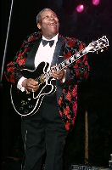King B B (Riley)

1925–

US blues guitarist, singer, and songwriter. One of the most influential electric-guitar players, he became an international star in the 1960s. His albums include Blues Is King 1967, Lucille Talks Back 1975, and Blues ’n’ Jazz 1983.
GSP GSP

