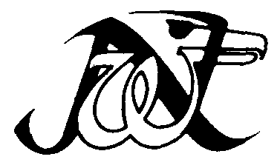
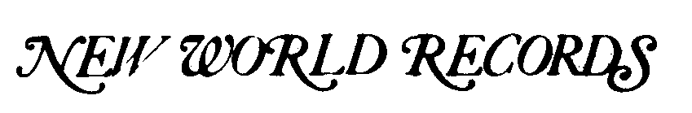

LET'S GET LOOSE

Folk and Popular Blues Styles
from the Beginnings to the Early 1940s
RECORDED ANTHOLOGY OF AMERICAN MUSIC, INC.

Program consultant: David Evans
Rerecording engineer: Frank Scott,
Advent Productions Mastering: Lee Hulko, Sterling Sound
Cover art: J. J. Lankes, "Spring Twilight," Woodcut.
Private collection, New York.
Cover design: Elaine Sherer Соx
Library of Congress Card No. 78-750470
©1978 © 1978 Recorded Anthology of American Music, Inc.
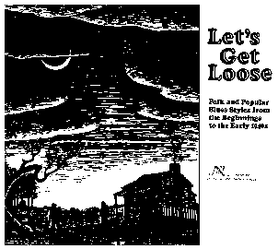
Side One
Total time 24:38
1. PEACH TREE BLUES (Yank Rachell)................... 2:44
(publ. Duchess Music Corporation) Yank Rachell, vocal and guitar; Sonny Boy Williamson, harmonica; Alfred Elkins, washtub bass; Washboard Sam, washboard. R.1941
2. BROWNSKIN WOMAN................................. 3:19
Pillie Bolling, vocal and guitar. R.1930
3. VIOLIN BLUES......................................... 3:16
The Johnson Boys: T. C. Johnson, guitar; Nap Hayes, vocal and violin; Matthew Prater, mandolin. R. 1928
4. WHAT'S THE MATTER NOW?......................... 3:12
(publ. MCA Music, A Division of MCA, Inc.) Monarch Jazz Quartet of Norfolk, vocals . R.1929
5. YODELING BLUES..................................... 2:56
(рubl. MCA Music, A Division of MCA, Inc.)
Buck Mountain Band: probably Earl Edwards, vocal and
guitar; Van Edwards, fiddle; Wade Ward, banjo. R.1929
6. DOGGONE MY GOOD LUCK SOUL................... 3:06
Hattie Hudson, vocal; Willie Tyson, piano. R.1927
7. LET'S GET LOOSE (Gray)............................. 2:40
Clara Smith, vocal; Ed Allen, cornet;
unknown clarinet and piano. R.1929
8. NIGGER BLUES (Leroy "Lasses" White)................ 2:54
George O'Connor, vocal; unknown trumpets, trombone, tuba, and clarinet, with simulated train noises. R.1916

Side Two
Total time 24:28
1. DAD'S OLE MULE (Charles and Effie Tyus)............. 3:14
Tyus and Tyus, vocals; unknown cornet and piano. R.1931
2. KEEP IT CLEAN....................................... 3:24
Rufus and Ben Quillian: Rufus Quillian, vocal and piano;
Ben Quillian, vocal; James McCrary, vocal and guitar. R.1930
3. BLUE NIGHT BLUES (Leroy Carr)...................... 2:53
Leroy Carr, vocal and piano;
Francis "Scrapper" Blackwell, guitar. R.1934
4. HOUSE LADY BLUES.................................. 2:53
Walter Roland, vocal and piano. R.1939
5. I'M CUTTIN' OUT (Wilber "Joe" McCoy and
Herb Morand)........................................ 2:36
Harlem Hamfats: Wilber "Joe" McCoy, vocal; Herb Morand, trumpet; Odell Rand, clarinet; Horace Malcolm, piano;
John Lindsay, string bass; Fred Flynn or Pearlis Williams, drums. R.!937
6 DEEP BLUE SEA BLUES (Tommy McClennan).......... 2:57
Tommy McClennan, vocal and guitar; unknown string bass. R.1941
7. LOVE ME, BABY (John Lee "Sonny Boy" Williamson)... 3:20 John Lee "Sonny Boy" Williamson, vocal and harmonica;
Big Bill Broonzy, guitar; Blind John Davis, piano;
Alfred Elkins, one-string bass. R. 1942
8. MY BUDDY BLUES (Eugene Gilmore).................. 2:46
The Five Breezes: Gene Gilmore, lead vocal; Leonard
"Baby Doo" Caston, vocal and guitar; Joseph Bell and
Willie Hawthorne, vocals; Willie Dixon, one-string bass. R.1940
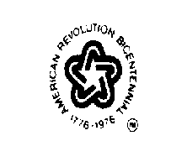

THESE RECORDINGS WERE MADE POSSIBLE THROUGH A GRANT
FROМ THE ROCKEFELLER FOUNDATION
NW 290 MONO

