Ricercar / Easter Cantata
Gordon Jones (Performer), Johann Sebastian Bach (Composer), Anton Webern (Composer), Christoph Poppen (Conductor), David James (Performer), Munich Chamber Orchestra (Performer, Orchestra), Monika Mauch (Performer), Rogers Covey-Crump (Performer)
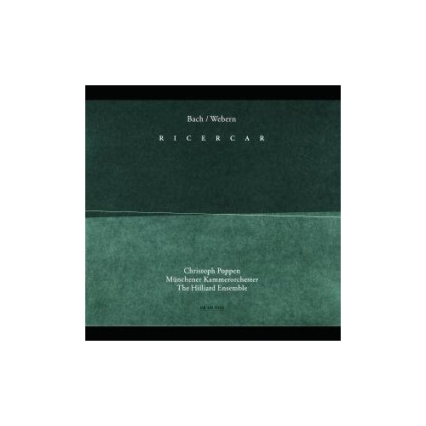
Product Details
- Composer: Johann Sebastian Bach, Anton Webern
- Conductor: Christoph Poppen
- Performer: Gordon Jones, David James, Munich Chamber Orchestra, Monika Mauch, Rogers Covey-Crump
- Orchestra: Munich Chamber Orchestra
- Audio CD (April 1, 2003)
- SPARS Code: DDD
- Number of Discs: 1
- Label: Ecm Records
- ASIN: B00008HCEY

1. Musical Offering, BWV 1079 - Transcription: Anton Webern - Fuga (Ricercata) a 6 voci*Munchener Kammerorchester*8:51
2. String Quartet (1905) - Orchestrated by Christoph Poppen - String Quartet (1905)*Munchener Kammerorchester*19:25
3. Cantata "Christ lag in Todesbanden", BWV 4 - 1. Sinfonia - Versus 1: Coro*The Hilliard Ensemble*5:17
4. Cantata "Christ lag in Todesbanden", BWV 4 - 2. Versus 2: Duetto (Soprano, Alto)*The Hilliard Ensemble*3:52
5. Cantata "Christ lag in Todesbanden", BWV 4 - 3. Versus 3: Aria (Tenore)*The Hilliard Ensemble*2:03
6. Cantata "Christ lag in Todesbanden", BWV 4 - 4. Versus 4: Coro*The Hilliard Ensemble*2:18
7. Cantata "Christ lag in Todesbanden", BWV 4 - 5. Versus 5: Aria (Basso)*The Hilliard Ensemble*3:05
8. Cantata "Christ lag in Todesbanden", BWV 4 - 6. Versus 6: Duetto (Soprano, Tenore) - Versus 7: Choral*The Hilliard Ensemble*3:01
9. 5 Movements for String Quartet, Op.5 - 1. Heftig bewegt*Munchener Kammerorchester*2:53
10. 5 Movements for String Quartet, Op.5 - 2. Sehr langsam*Munchener Kammerorchester*2:26
11. 5 Movements for String Quartet, Op.5 - 3. Sehr lebhaft*Munchener Kammerorchester*0:43
12. 5 Movements for String Quartet, Op.5 - 4. Sehr langsam*Munchener Kammerorchester*1:56
13. 5 Movements for String Quartet, Op.5 - 5. In zarter Bewegung*Munchener Kammerorchester*4:02
14. Musical Offering, BWV 1079 - Transcription: Anton Webern - Fuga (Ricercata) a 6 voci*Munchener Kammerorchester*9:10

On this CD:
- The Musical Offering (Musikalisches Opfer), for keyboard and chamber instruments, BWV 1079 Fuga (Ricercata) a 6 voci
Composed by Johann Sebastian Bach
with Munich Chamber Orchestra
Conducted by Christoph Poppen
- String Quartet (1905)
Composed by Anton Webern
with Munich Chamber Orchestra
Conducted by Christoph Poppen
- Cantata No. 4, "Christ lag in Todes Banden," BWV 4 (BCA 54)
Composed by Johann Sebastian Bach
with Monika Mauch, Hilliard Ensemble, Rogers Covey-Crump, Munich Chamber Orchestra, Gordon Jones, David James
Conducted by Christoph Poppen
- Movements (5) for string quartet, Op. 5
Composed by Anton Webern
with Munich Chamber Orchestra
Conducted by Christoph Poppen
- The Musical Offering (Musikalisches Opfer), for keyboard and chamber instruments, BWV 1079 Fuga (Ricercata) a 6 voci
Composed by Johann Sebastian Bach
with Munich Chamber Orchestra
Conducted by Christoph Poppen

