Frye: Missa Flos Regalis, Motets, Songs - Hilliard Ensemble
Walter Frye (Artist), Hilliard Ensemble (Artist), Paul Hillier (Artist), David James (Artist), Gordon Jones (Artist), Rogers Covey-Crump (Artist), John Potter (Artist)

Product Details
- Audio CD (May 10, 1994)
- SPARS Code: DDD
- Number of Discs: 1
- Label: Ecm Records
- ASIN: B0000031X7
1. Trinitatis Dies
2. Gloria (Missa Flos Regalis)
3. Salve Virgo
4. Credo (Missa Flos Regalis)
5. O Florens Rosa
6. Sanctus (Missa Flos Reglis)
7. Agnus Dei (Missa Flos Reglis)
8. Ave Regina
9. Ave Regina
10. Sospitati Dedit
11. Tou A Par Moi
12. So Ys Emprentid
13. Myn Hertis Lust
14. Alas, Alas Is My Chief Song

The Hilliard Ensemble - Walter Frye

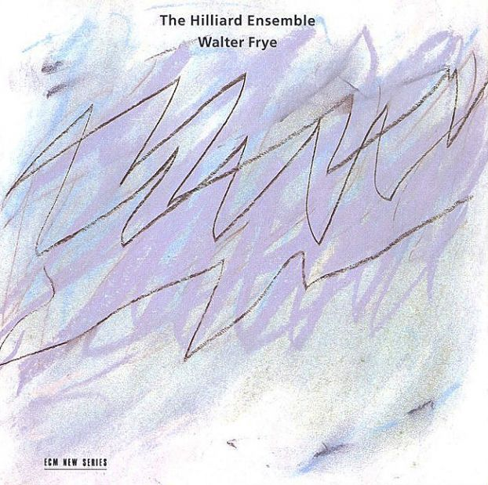
Year: 1992
Country: England
Style: Sacred music
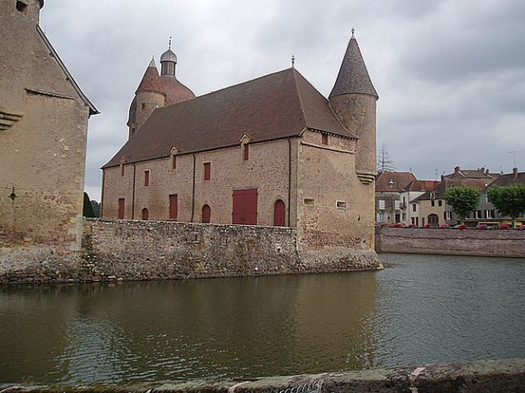
Very little is known of Walter Frye (d.1474) except that he was presumably an English composer working on the Continent in the middle decades of the 15th century. A few of his compositions were quite famous, especially the motet Ave regina. The present Mass cycle is one of three by Frye, all surviving together in a Burgundian manuscript possibly copied as a wedding gift for an English royal bride.

TrackList:

01 - Trinitatis dies
02 - Missa Flos Regalis - Gloria
03 - Salve virgo
04 - Missa Flos Regalis - Credo
05 - O florens rosa
06 - Missa Flos Regalis - Sanctus
07 - Missa Flos Regalis - Agnus Dei
08 - Glogauer Liederbuch - Ave regina
09 - Codex Specialnik - Ave regina
10 - Sospitati dedit
11 - Tout a par moi
12 - So ys emprentid
13 - Myn hertis lust
14 - Alas, alas is my chief song

Performers:

David James, Rogers Covey-Crump, John Potter, Gordon Jones

