Hilliard Live 4: Guillaume Dufay
Dufay (Artist), Hilliard Live (Artist)

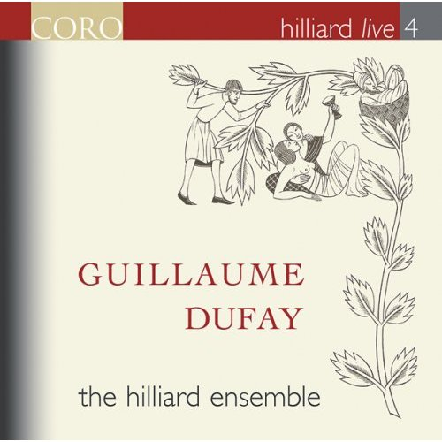

Product Details
- Audio CD (February 12, 2008)
- Number of Discs: 1
- Label: Coro
- ASIN: B0012EBXNG

01 Kyrie and Gloria (Missa Se la Face ay Pale)
02 Fios Florum
03 Credo
04 Anima mea
05 Moribus
06 Sanctus and Benedictus
07 Vergene Bella
08 Ave Regina
09 Agnus Dei
10 Exultat celum laudibus

