In Paradisum: Music of Victoria and Palestrina [ORIGINAL RECORDING REISSUED]
Victoria (Artist), Palestrina (Artist), Hilliard Ensemble (Artist)
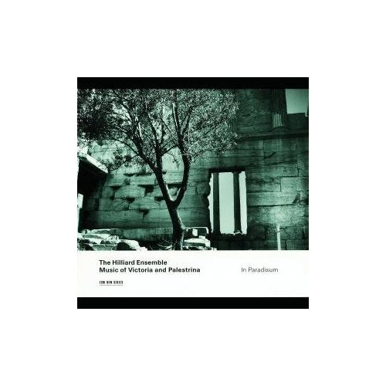
Product Details
- Audio CD (April 25, 2000)
- SPARS Code: DDD
- Number of Discs: 1
- Format: Original recording reissued
- Label: Ecm Records
- ASIN: B00004RKMI

1. Officium defunctorum (1605) - Taedet Animam Meam*3:55
2. Introitus*2:43
3. Kyrie*1:48
4. Domine Quando Veneris*5:41
5. Graduale*2:49
6. Officium defunctorum 1592 - Libera me Domine*11:01
7. Tractus*2:40
8. Ad Dominum Cum Tribularer Clamavi*5:26
9. Sequentia - Dies Irae*5:17
10. Offertorium*4:50
11. Officium defunctorum 1592 - Peccantem me quotidie*5:01
12. Sanctus - Benedictus*1:09
13. Heu Mihi Domine*6:59
14. Agnus Dei*1:09
15. Communio*1:23
16. Libera Me Domine*13:22

On this CD:
- Taedet animam meam, responsory for 6 voices (Missa Pro defunctis II)
Composed by Tomas Luis de Victoria
with Rogers Covey-Crump, John Potter, Gordon Jones, David James
- Introitus
Composed by Toul Graduale Romanum Anonymous
with Rogers Covey-Crump, John Potter, Gordon Jones, David James
- Kyrie
Composed by Toul Graduale Romanum Anonymous
with Rogers Covey-Crump, John Potter, Gordon Jones, David James
- Domine quando veneris, motet for 4 voices (from Motets Book II for 4 voices)
Composed by Giovanni Pierluigi da Palestrina
with Rogers Covey-Crump, John Potter, Gordon Jones, David James
- Graduale
Composed by Toul Graduale Romanum Anonymous
with Rogers Covey-Crump, John Potter, Gordon Jones, David James
- Libera me, responsory for 4 voices (Missa pro defunctus I)
Composed by Tomas Luis de Victoria
with Rogers Covey-Crump, John Potter, Gordon Jones, David James
- Tractus
Composed by Toul Graduale Romanum Anonymous
with Rogers Covey-Crump, John Potter, Gordon Jones, David James
- Ad Dominum cum tribularer, motet for 4 voices (from Motets Book II for 4 voices)
Composed by Giovanni Pierluigi da Palestrina
with Rogers Covey-Crump, John Potter, Gordon Jones, David James
- Sequentia
Composed by Toul Graduale Romanum Anonymous
with Rogers Covey-Crump, John Potter, Gordon Jones, David James
- Offertorium
Composed by Toul Graduale Romanum Anonymous
with Rogers Covey-Crump, John Potter, Gordon Jones, David James
- Peccantem me quotidie, responsory for 4 voices (Missa Pro defunctis I)
Composed by Tomas Luis de Victoria
with Rogers Covey-Crump, John Potter, Gordon Jones, David James
- Sanctus - Benedictus
Composed by Toul Graduale Romanum Anonymous
with Rogers Covey-Crump, John Potter, Gordon Jones, David James
- Heu mihi Domine, motet for 4 voices (from Motets Book II for 4 voices)
Composed by Giovanni Pierluigi da Palestrina
with Rogers Covey-Crump, John Potter, Gordon Jones, David James
- Agnus Dei
Composed by Toul Graduale Romanum Anonymous
with Rogers Covey-Crump, John Potter, Gordon Jones, David James
- Communio
Composed by Toul Graduale Romanum Anonymous
with Rogers Covey-Crump, John Potter, Gordon Jones, David James
- Libera me, motet for 3 voices (doubtful)
Composed by Giovanni Pierluigi da Palestrina
with Rogers Covey-Crump, John Potter, Gordon Jones, David James

