Jan Garbarek - The Hilliard Ensemble - Mnemosyne

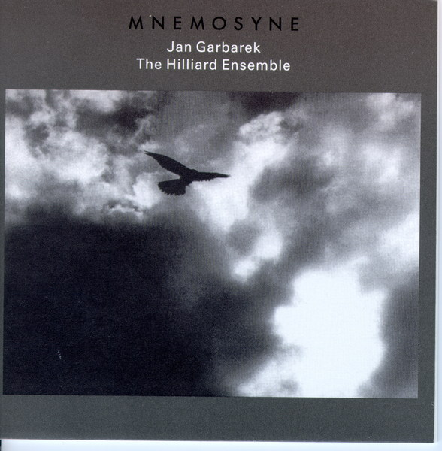
Жанр: Jazz & Classic
Год выпуска: 1998
Формат: APE (image + .cue)

Трэклист:

Disc: 1
1. Quechuna Song - Anonymus
2. O Lord In Thee Is All My Trust
3. Estonian Lullaby
4. Remember Me My Dear - Anonymus
5. Gloria
6. Fayrfax Africanus
7. Agnus Dei
8. Novus novus - Anonymus
9. Se je fayz dueil
10. O ignis spiritus

Disc: 2
1. Alleluia nativitatis - Anonymus
2. Delphic Paean
3. Strophe and Counter-Strophe
4. Mascarades - Anonymus
5. Loiterando
6. Estonian Lullaby
7. Russian Psalm - Anonymus
8. Eagle Dance
9. When Jesus Wept
10. Hymn To The Sun

Доп. информация:

# Composer: Jan Garbarek, Scottish Anonymous, Athenaeus, William Billings, Antoine Brumel, et al.
# Performer: Hilliard Ensemble
# Orchestra: Jan Garbarek
# Audio CD (October 5, 1999)
# Number of Discs: 2
# Label: Ecm Records
# ASIN: B00000K2AC

