Lilies: Original Motion Picture Soundtrack [SOUNDTRACK]
Mychael Danna

Product Details
- Audio CD (October 10, 2000)
- Original Release Date: October 21, 1997
- Number of Discs: 1
- Format: Soundtrack
- Label: Varese Sarabande
- ASIN: B00000152M

1. Libera Me
2. Ave Vernum Corpus
3. Kyrie I
4. Kyrie II
5. Gloria
6. Lux Aeterna
7. Alleluia, Justus Germinabit
8. Sanctus I
9. Sanctus II
10. Benedictus I
11. Benedictus II
12. Laminations Of Jeremiah
13. In Paradisum
14. Dies Irae I
15. Dies Irae II
16. Pie Jesu
17. Libera Me
18. Angus Dei

On this CD:
- Lillies, film score
Composed by Mychael Danna
with Kirk Worthington, Kenan Burrows, Hilliard Ensemble, David Gould

Lilies - OST - Mychael Danna
The Hilliard Ensemble

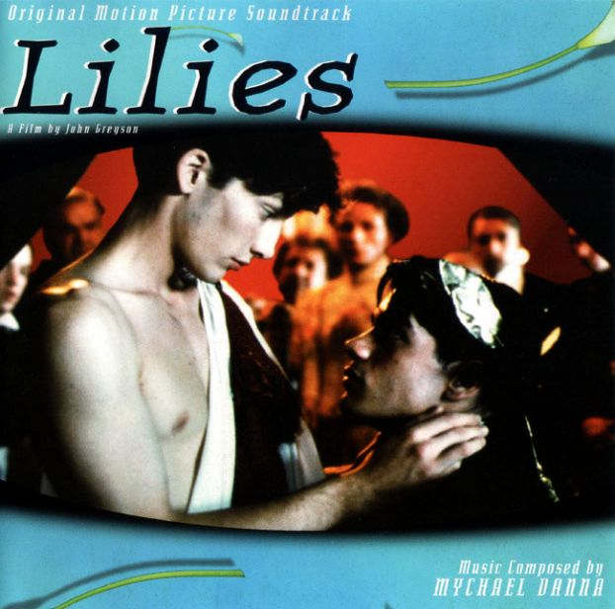
Year: 1997
Country: England
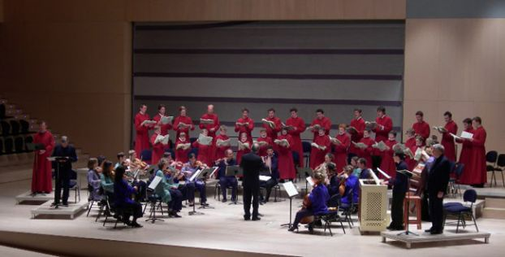
TrackList:

01 - Libera Me I
02 - Ave Verum Corpus
03 - Kyrie I
04 - Kyrie II
05 - Gloria
06 - Lux Aeterna
07 - Alleluia, Justus Germinabit
08 - Sanctus I
09 - Sanctus II
10 - Benedictus I
11 - Benedictus II
12 - Lamentations of Jeremiah
13 - In Paradisum
14 - Dies Irae I
15 - Dies Irae II
16 - Pie Jesu
17 - Libera Me II
18 - Agnus Dei

Performers:

The Hilliard Ensemble:

David James, John Potter, Gordon Jones, Rogers Covey-Crump

David Gould - countertenor
Kenan Burrows - soprano
Kirk Worthington - cello
Robert Grim - trumpet

