PEROTIN (1160-1230) Pérotin and the Ars Antiqua - The Hilliard Ensemble
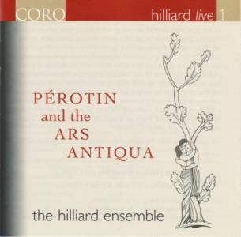

PEROTIN (1160-1230) Pérotin and the Ars Antiqua - The Hilliard Ensemble
DDD | TT: 68:14 Recording live in the chapel of Trinity College, Cambridge, 1 August 1996
The Hilliard Ensemble
David James countertenor
Rogers Covey-Crump tenor
John Potter tenor
Gordon Jones baritone
infos
Tracklisting:
1. Vetus Abit Littera
2. Deus Misertus Hominis
3. Veni Creator Spiritus
4. Viderunt Omnes
5. Gloria: Redemptori Meo
6. Haec Dies
7. Strips Lesse
8. Mudus Vergens
9. Procurans Odium
10. Alleluia. Nativitas
11. Christus Surrexit
12. Sederunt Principes

