Sacred and Secular Music from Six Centuries [IMPORT]
Paul Hillier (Performer), Michael George (Performer), Anonymous (Composer), William Byrd (Composer), Guillaume Dufay (Composer), Robert Fayrfax (Composer), Mateo (i) Flecha (Composer), Godefroy De St Victoire (Composer), Claude Goudimel (Composer), Hermanus Contractus (Composer), Heinrich Isaac (Composer), Clement Janequin (Composer), Guillaume de Machaut (Composer), Francisco de Penalosa (Composer), Thomas Tallis (Composer), David James (Performer), John Potter (Performer), Rogers Covey-Crump (Performer)

Product Details
- Composer: Anonymous, William Byrd, Guillaume Dufay, Robert Fayrfax, Mateo (i) Flecha, et al.
- Performer: Paul Hillier, Michael George, David James, John Potter, Rogers Covey-Crump
- Audio CD (February 10, 2004)
- SPARS Code: DDD
- Number of Discs: 1
- Format: Import
- Label: Hyperion UK
- ASIN: B0000Y37MO
On this CD:
- Salve Regina
Composed by Hermanus Contractus
with David James
- Planctus Ante Nescia
Composed by Godefroy De St Victoire
with John Potter, Paul Hillier
- Quant je sui mis su retour, virelai for voice
Composed by Guillaume de Machaut
with Rogers Covey-Crump
- Vergene bella, cantilena motet for 3 voices
Composed by Guillaume Dufay
with Rogers Covey-Crump, John Potter, David James
- Gloria ad modum tubae, for 4 voices
Composed by Guillaume Dufay
with Michael George, Rogers Covey-Crump, John Potter, Paul Hillier
- Most Clere of Colour for 3 voices
Composed by Robert Fayrfax
with Rogers Covey-Crump, John Potter, David James
- O nata lux de lumine, motet (hymn) for 5 voices, P. 209
Composed by Thomas Tallis
with Hilliard Ensemble
- Ne irascaris (also anthems: "Let not Thy wrath" & "O Lord, turn thy wrath"), motet for 5 voices (SATBar (or T) B)
Composed by William Byrd
with Hilliard Ensemble
- Dezi, Flor Resplandeciente
Composed by Anonymous
with John Potter, Paul Hillier, David James
- Nuevas, Nuevas, Por Tu Fe!
Composed by Anonymous
with Rogers Covey-Crump, John Potter, Paul Hillier
- Sancta Mater Istud Agas, motet for 4 voices
Composed by Francisco de Penalosa
with Rogers Covey-Crump, John Potter, Paul Hillier, David James
- El Jubilate
Composed by Mateo (i) Flecha
with Rogers Covey-Crump, John Potter, Paul Hillier, David James
- Tota pulchra es, motet for 4 voices
Composed by Heinrich Isaac
with Rogers Covey-Crump, John Potter, Paul Hillier, David James
- Bonjour Mon Coeur
Composed by Claude Goudimel
with Rogers Covey-Crump, John Potter, Paul Hillier, David James
- Reveillez vous, cueurs endormis, chanson for 4 voices ("Le chant des oiseaux"), M. 2/67
Composed by Clement Janequin
with Rogers Covey-Crump, John Potter, Paul Hillier, David James
Sacred and Secular Music from Six Centuries [IMPORT]
Michael George (Performer), Paul Hillier (Performer), Anonymous (Composer), William Byrd (Composer), Guillaume Dufay (Composer), Robert Fayrfax (Composer), Mateo (i) Flecha (Composer), Godefroy De St Victoire (Composer), Claude Goudimel (Composer), Hermanus Contractus (Composer), Heinrich Isaac (Composer), Clement Janequin (Composer), Guillaume de Machaut (Composer), Francisco de Penalosa (Composer), Thomas Tallis (Composer), Hilliard Ensemble (Performer), John Potter (Performer), David James (Performer), Rogers Covey-Crump (Performer)
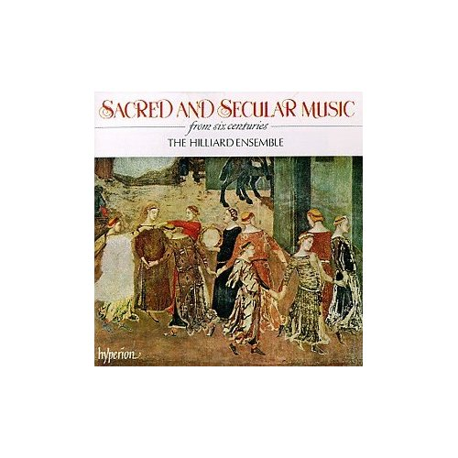
Product Details
- Composer: Anonymous, William Byrd, Guillaume Dufay, Robert Fayrfax, Mateo (i) Flecha, et al.
- Performer: Michael George, Paul Hillier, Hilliard Ensemble, John Potter, David James, et al.
- Audio CD (September 10, 1992)
- SPARS Code: DDD
- Number of Discs: 1
- Format: Import
- Label: Hyperion
- ASIN: B000002ZMI
1. Sacred And Secular Music From Six Centuries: Salve Regina
2. Sacred And Secular Music From Six Centuries: Planctus ante nescia
3. Sacred And Secular Music From Six Centuries: Quant jue sui mis
4. Sacred And Secular Music From Six Centuries: Vergene bella
5. Sacred And Secular Music From Six Centuries: Glorai ad modem tubae
6. Scared And Secular Music From Six Centuries: Most clear of colour
7. Sacred And Secular Music From Six Centuries: O nata lux - Thomas Tallis
8. Sacred And Secular Music From Six Centuries: Ne irascaris Domine - Cititas sancti tui
9. Dezi, flor rresplandeciente - Anonymous
10. Nuevas, nuevas Por tu fe! - Anonymous
11. Sacred And Secular Music From Six Centuries: Sancta Mater
12. Sacared And Secular Music From Six Centuries: El Jubilate
13. Sacred And Secular Music From Six Centuries: Tota pulcra es
14. Sacared And Secular Music From Six Centuries: Bonjour mon coeur
15. Sacred And Secular Music From Six Centuries: Le Chant des Oiseaulx

